INSTITUTE OF FOREIGN LANGUAGES
100
40

ENGLISH LANGUAGE TEST – INTERMEDIATE
(mock test)
Name

PART ONE – READING

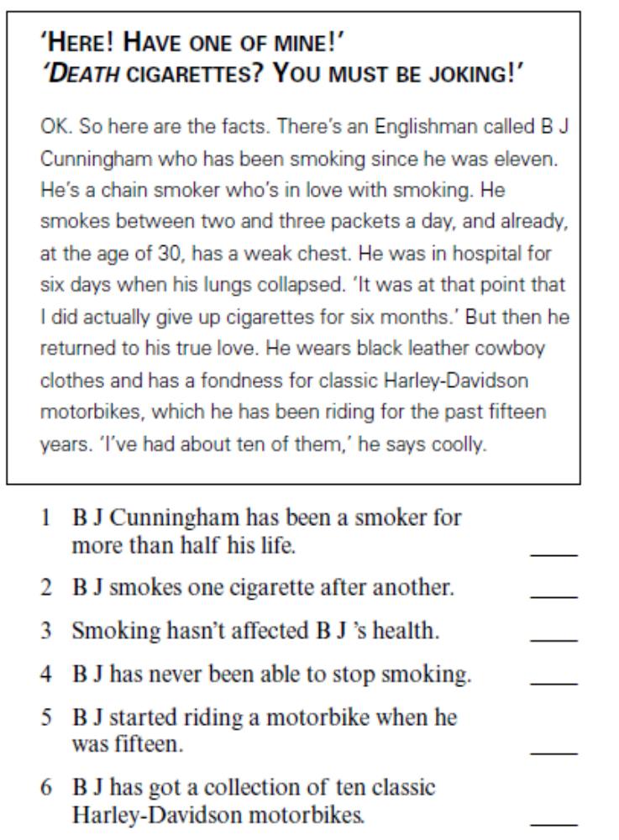

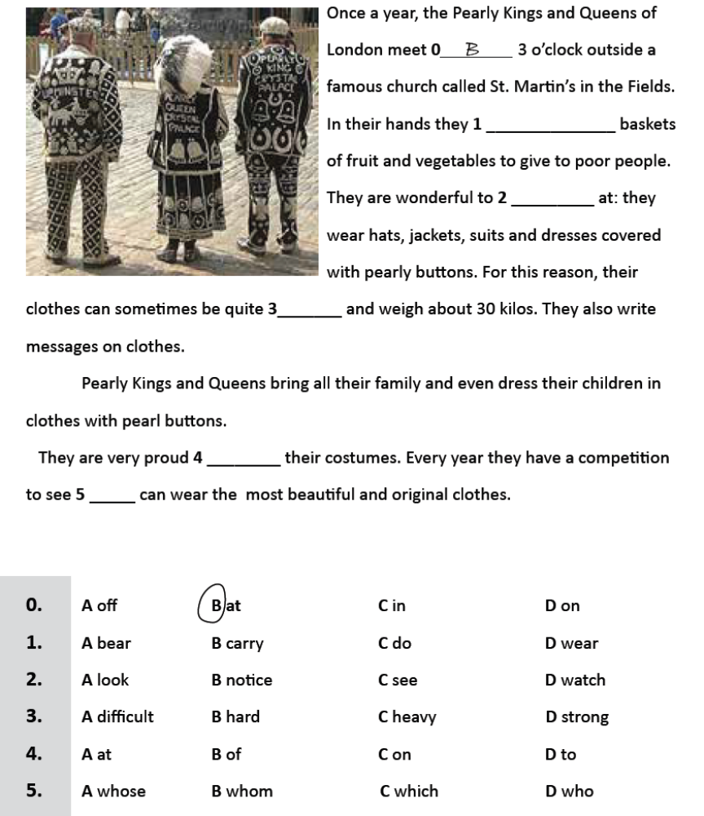

0. | 1. | 2. | 3. | 4. | 5.
B

PART TWO – LANGUAGE IN USE

A.
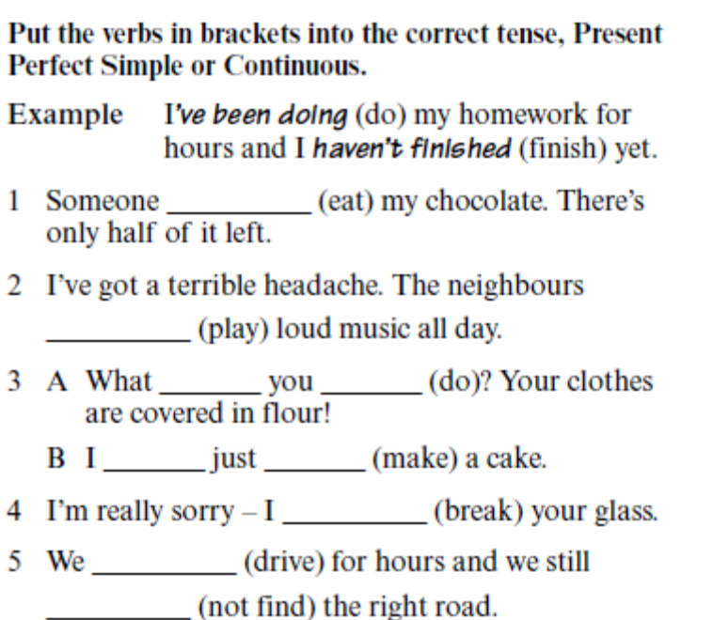

B.
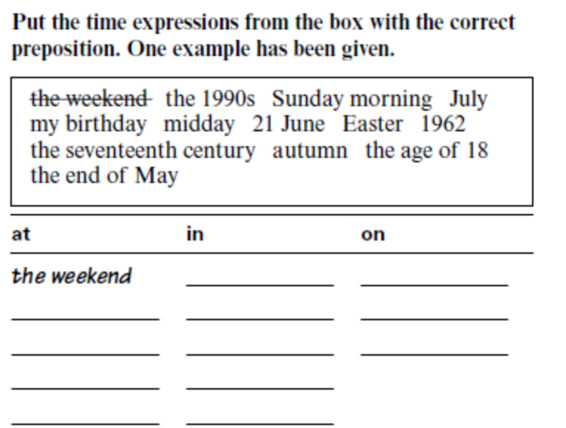

E.
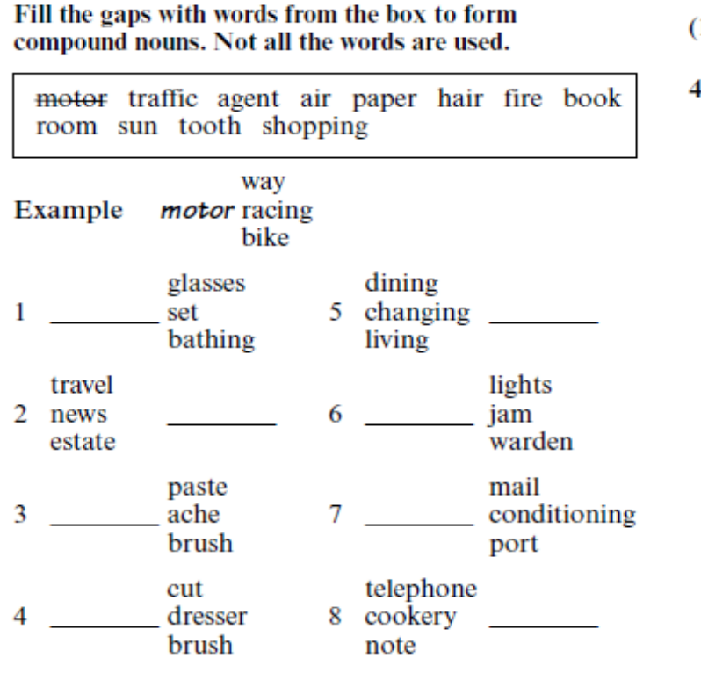

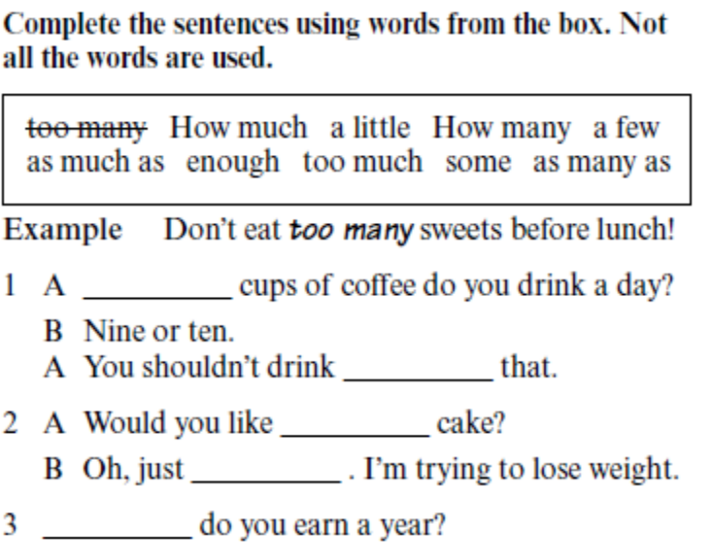

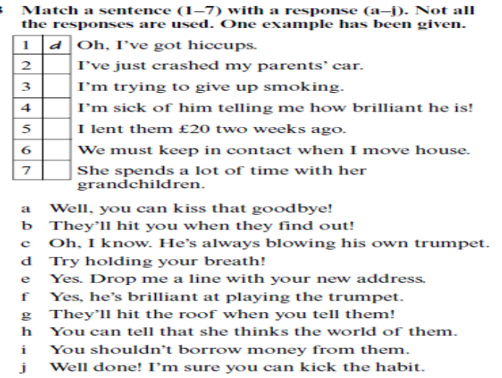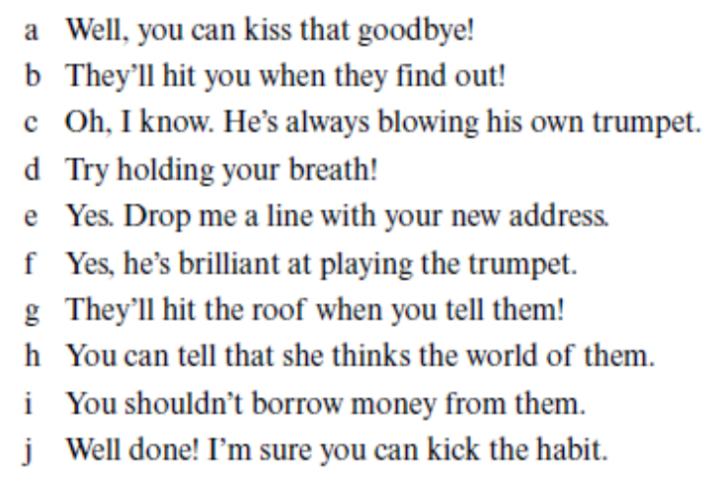

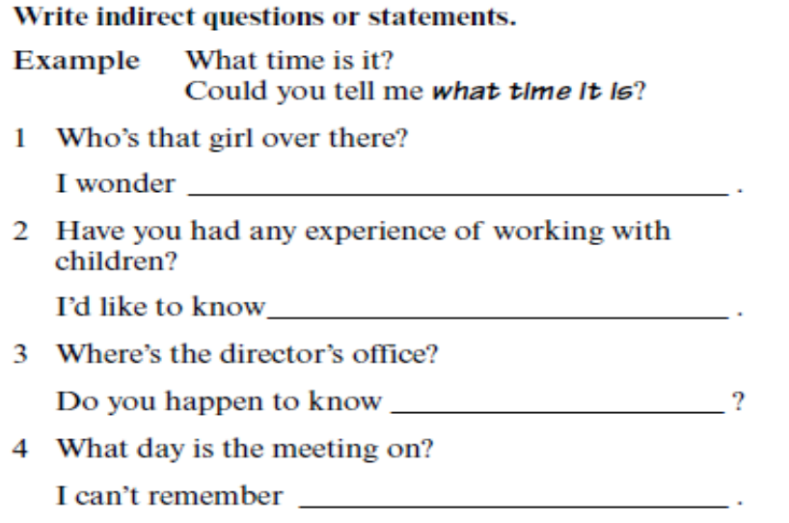

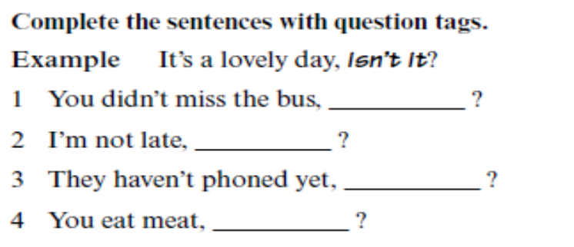
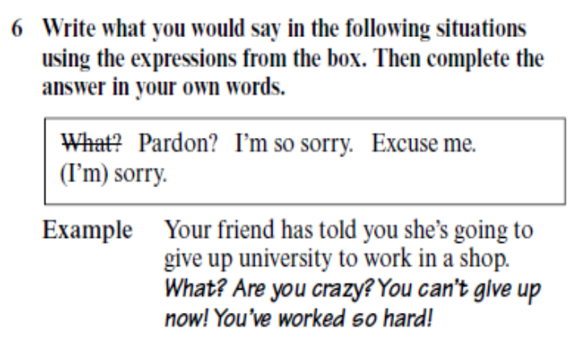
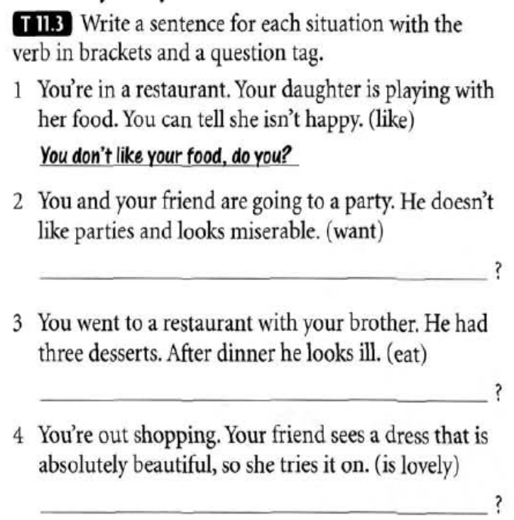

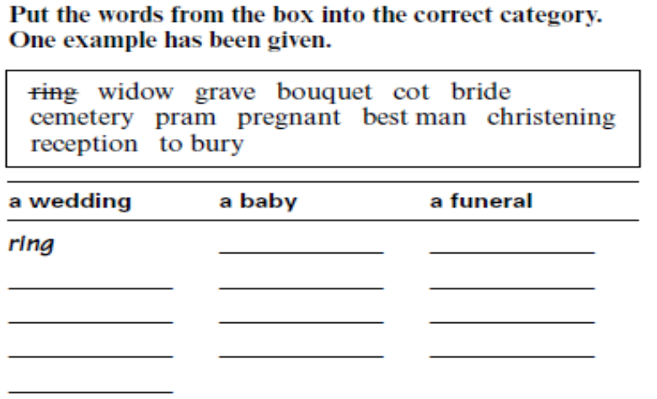

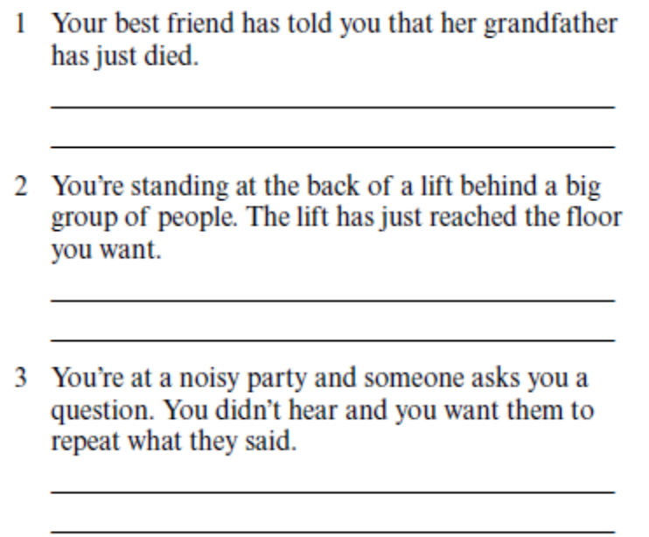

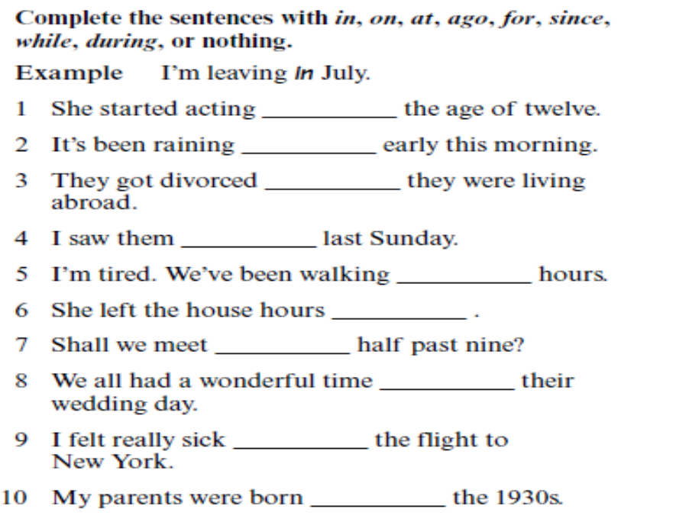

TURN THE FOLLOWING SENTENCES FROM DIRECT INTO REPORTED SPEECH:

1. "I am having a lot of success with that project", said Monica.
...............................................................................................................................................................
2. "Don’t swim too far", the teacher said to us.
...............................................................................................................................................................
3. "We must finish dinner soon", she told us.
...............................................................................................................................................................
4. "Set the table for lunch and don’t forget the fancy napkins", Jane said to him.
...............................................................................................................................................................
5. "She goes to gym twice a week and catches 10 p.m. bus", Rosie said to Jonathan.
...............................................................................................................................................................
6. "We were very happy to hear that", James admitted.
...............................................................................................................................................................

COMPLETE THE FOLLOWING SENTENCES WITH THE APPROPRIATE FORMS OF THE GIVEN MULTI-WORD VERBS.

take up look back on look forward look down on set off

- Panic on the stock market __________ a wave of selling.
- She ____________ people who haven't been to college.
- She likes to _____________ her childhood.
- We are _______________ to your reply.
- It will _____________ a lot of our time.

CORRECT THE MISTAKES.

1. We have a lot of fun on Christmas.
....................................................................................................................................................................................
2. You really shouldn’t smoke as much cigarettes as your father.
....................................................................................................................................................................................
3. I am supposed to be there at noon, amn’t I?
....................................................................................................................................................................................
4. He told me to not to go away.
....................................................................................................................................................................................

TRANSLATE THE FOLLOWING SENTENCES.

- When men first flew in space, they were amazed to discover that the only man-made object visible from orbit was the Great Wall of China.
....................................................................................................................................................................................
....................................................................................................................................................................................
- Evidence suggests that boys are the weaker sex at birth, which means that more die in infancy.
....................................................................................................................................................................................
- B J Cunningham has misunderstood human psychology because smokers know that their habit is probably going to kill them, but they prefer not to think about it.
....................................................................................................................................................................................
....................................................................................................................................................................................
- John, you couldn’t give me a lift to the station, could you?
....................................................................................................................................................................................
- Pitam se ko je ona.
....................................................................................................................................................................................
- Pitao sam se ko je ona.
....................................................................................................................................................................................
- Rekla je da mi ne može pomoći jer je prezauzeta.
....................................................................................................................................................................................
- Bio bih vam jako zahvalan ako biste mi mogli poslati vašu brošuru.
....................................................................................................................................................................................
- Rekla mu je da ne može izaći s njim sjutra.
....................................................................................................................................................................................
- Savjetovao mi je da idem kod ljekara.
....................................................................................................................................................................................
- Zaista se radujem praznicima.
....................................................................................................................................................................................
- On se požalio da je izgubio novac.
....................................................................................................................................................................................
- Koliko vina želite?
....................................................................................................................................................................................
- Nisam siguran kada će on doći.
....................................................................................................................................................................................

PART THREE – WRITING

MY FAVOURITE MOVIE/BOOK/TV SHOW/GROUP/SONG/SINGER
CHOOSE ONE OF THE TOPICS LISTED ABOVE AND WRITE A SHORT PARAGRAPH.
……………………………………………………………………………………………………………………………………………………………………………………………....
……………………………………………………………………………………………………………………………………………………………………………………………....
……………………………………………………………………………………………………………………………………………………………………………………………....
……………………………………………………………………………………………………………………………………………………………………………………………....
……………………………………………………………………………………………………………………………………………………………………………………………....
……………………………………………………………………………………………………………………………………………………………………………………………....
……………………………………………………………………………………………………………………………………………………………………………………………....
……………………………………………………………………………………………………………………………………………………………………………………………....
……………………………………………………………………………………………………………………………………………………………………………………………....
……………………………………………………………………………………………………………………………………………………………………………………………....
……………………………………………………………………………………………………………………………………………………………………………………………....
……………………………………………………………………………………………………………………………………………………………………………………………....
……………………………………………………………………………………………………………………………………………………………………………………………....
……………………………………………………………………………………………………………………………………………………………………………………………....

