UNIVERZITET CRNE GORE
INSTITUT ZA STRANE JEZIKE

EKONOMSKI FAKULTET

PRIPREMA ZA ZAVRŠNI ISPIT

ENGLESKI JEZIK (III STEPEN)

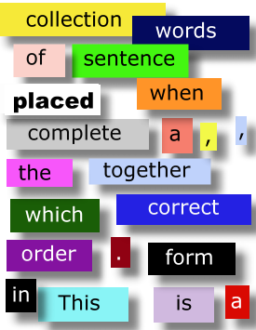

PRIREDIO: DANILO ALAGIĆ

PODGORICA, MAJ 2014.

PART ONE – GRAMMAR

THE PAST AND PERFECT TENSES
1.1. THE SIMPLE PAST TENSE (PROSTO SVRŠENO VRIJEME)
Da bi napravili prošlo svršeno vrijeme koristimo infinitiv i prošli oblik (preterit) glagola.
infinitive | Simple Past  (preterit)
work  explode  like | worked  exploded  liked | Prošli oblik ovih  glagola završava se  na -ed.
go  see  sing | went  saw  sang | Prošli oblik nepravilnih  glagola se ne gradi po nekom pravilu i uči se  napamet.
Pravilni
glagoli

Nepravilni
glagoli
Tvorba prošlog svršenog vremena:
a) potvrdna rečenica:
subjekat + glavni glagol u prošlom obliku (preteritu)
I lived in that house when I was young. (Živio sam u toj kući kada sam bio mlad)
She played basketball last week. (Ona je igrala košarku prošle sedmice)

b) odrična rečenica:
subjekat + preterit od "do"(did) + not + infinitiv glavnog glagola
He didn't like the movie. (Nije mu se dopao film)
Mary did not go to work last Monday. (Meri nije otišla na posao prošlog ponedjeljka)
c) upitna rečenica (YES/NO questions)

preterit od "do"(did) + subjekat + infinitiv glavnog glagola
Did you play tennis last week. (Jesi li igrao tenis prošle sedmice?) (nikako: Did you played…!!!!)
Did he watch TV last night. (Je li gledao TV prošle sedmice?) (nikako: Did he watched…!!!)
Glagol did (preterit od "do") u svim licima ima isti oblik.
I did not go to London. (nisam bio u Londonu)
You did not go to London.
He did not go to London. itd.
Glagol to be nema u svim licima isti oblik, upitnu rečenicu pravimo zamjenom subjekta i glagola (inverzija!):
I, he, she, it was here. - Was I, he, she, it here?
You were here. - Were you here?

- Ako glagol završava na suglasnik ispred kojeg stoji kratak naglašen vokal, krajnji samoglasnik se udvostručava:
plan - planned
skip - skipped
- Krajnje "l" se uvijek udvostručava:
level - levelled
call - called
- Ako glagol završava na "-y" ispred kojeg se nalazi suglasnik, "y" se mijenja u "i" i dodajemo nastavak -ed:
worry - worried
cry - cried
Past Simple Tense (Preterite Tense) se koristi:
a) da se izrazi radnja koja se desila u prošlosti i potpuno završila pa nema nikakve veze sa sadašnjošću:
I was in Liverpool last year. (Bio sam u Liverpulu prošle godine);
b) da se izrazi radnja koja je trajala neko vrijeme u prošlosti bez ikakve veze sa sadašnjošću:
We went to school when we were children. (Išli smo u školu kada smo bili djeca);
c) kada govorimo o stvarima koje želimo da se dogode ili bi trebalo da se dogode:
It's time they were back. (Vrijeme je da se vrate)
I wish I had a new computer. (Volio bih da imam novi kompjuter)
Priloške odredbe uz koje se uvijek koristi Simple Past Tense su: yesterday, last night/week/month/Monday, two days/months/weeks ago, then, when, in 2003…
to call – zvati (pravilan glagol)
potvrdan oblik odričan oblik upitan oblik (YES/NO questions)
I called (ja sam zvao) | I didn't call | did I call?
you called | you didn't call | did you call?
he, she, it called | he, she, it didn't call | did he, she, it call?
we called | we didn't call | did we call?
you called | you didn't call | did you call?
they called | they didn't call | did they call?
to feel – osjećati (nepravilan glagol)
potvrdan oblik odričan oblik upitan oblik (YES/NO questions)
I felt (ja sam osjećao) | I didn't feel | did I feel?
you felt | you didn't feel | did you feel?
he, she, it felt | he, she, it didn't feel | did he, she, it feel?
we felt | we didn't feel | did we feel?
you felt | you didn't feel | did you feel?
they felt | they didn't feel | did they feel?

A. PUT THE VERBS IN BRACKETS INTO THE PAST SIMPLE TENSE.

1. When ………did your friend arrive………… (your friends, arrive) last night?
2. My brother …………………………….. (not to be) in France in 1971.
3. Robert and Jane …………………………….. (go) abroad last month.
4. My eldest daughter …………………………….. (visit) Italy last summer.
5. John …………………………….. (buy) some presents for his little son when he was in London.
6. We …………………………….. (not to discuss) the matter before dinner.
7. How many classes …………………………….. (you, have) yesterday?
8. When …………………………….. (your first term, begin)?
9. I …………………………….. (buy) some books last week.
10. Her mother …………………………….. (make) some very delicious cakes last Sunday.

KEY:

ex. A.
1. When ………did your friend arrive………… (your friends, arrive) last night?
2. My brother WAS NOT/WASN’T in France in 1971.
3. Robert and Jane WENT abroad last month.
4. My eldest daughter VISITEDItaly last summer.
5. John BOUGHT some presents for his little son when he was in London.
6. We DID NOT DISCUSS the matter before dinner.
7. How many classes DID YOU HAVE yesterday?
8. When DID YOUR FIRST TERM BEGIN?
9. I BOUGHT some books last week.
10. Her mother MADE some very delicious cakes last Sunday.

1.2. PAST CONTINOUS TENSE (NESVRŠENI PRETERIT)
prošlo vrijeme glagola "to be" + particip prezenta glavnog glagola
She was reading. (ona je čitala)
We were playing. (mi smo igrali)
- Odrični oblik se pravi dodavanjem rječice not:
She was not reading - She wasn't reading.

- Upitni oblik se pravi inverzijom:
Was she playing?
Were we playing?
Nesvršeni preterit se upotrebljava:
- da se opiše ambient, odnosno da se pred čitaoce postavi scena priče pisana u prošlom vremenu. Obično priča počinje nesvršenim preteritom, a zatim se nastavlja prošlim vremenom, npr:
"James Bond was driving through town. It was raining. The wind was blowing hard. Nobody was walking in the streets. Suddenly, Bond saw the killer in a telephone box...”
- da se opiše radnja koja je trajala do trenutka kada ju je prekinula neka druga prošla radnja (obično uz priloge when, while, as, i tada se Past Continuous koristi naporedo sa Simple Past Tensom):
I was having a beautiful dream when the alarm clock rang. (Divno sam sanjao kada se alarm oglasio.);
Past Continuous Simple Past
(radnja koja je prekinuta) (radnja koja prekida neku drugu prošlu radnju)
She was watching TV when you phoned her. (Gledala je TV kada si je nazvao.)
- da se izrazi promjena mišljenja:
I was going to spend the day at the beach but I've decided to go on an excursion instead. (Mislio sam provesti dan na plaži ali sam odlučio otići na ekskurziju)
- za dvije radnje koje se dešavaju istovremeno (obično uz prilog while):
The children were playing while their mothers were chatting. (Djeca su se igrala dok su njihove majke ćaskale.)
Kod glagola koji se ne koriste u trajnom obliku upotrebljava se obični preterit (understand, know, like, hate, love, mean, believe, seem, belong etc.).
Prilozi uz koje se koristi Past Continuous su when, while, as, kao i priloške odredbe all day/night/morning, at three/seven/eight o’clock yesterday afternoon i sl.

to call – zvati
potvrdan oblik odričan oblik upitan oblik (YES/NO questions)
I was calling. | I was not calling | was I calling?
you were calling. | you were not calling | were you calling?
he, she, it was calling | he, she, it wasn't calling | was he, she, it calling?
we were calling | we weren't calling | were we calling?
you were calling | you weren't calling | were you callingg?
they were calling | they weren't calling | were they calling?
EXERCISES
A. PUT THE VERB IN BRACKETS INTO THE PAST CONTINUOUS TENSE.

1. The sun …………………… (shine) when I went out.
2. When mother entered the room the children …………………… (sleep).
3. I met our teacher when I …………………… (go) to town.
4. She …………………… (sit) by the window when I passed by.
5. Mary …………………… (sit) at the table while her mother ……………………(prepare) lunch.
6. This time yesterday I …………………… (prepare) my lessons.
7. Mary …………………… (try) to phone Helen when I entered the room.
8. The teacher …………………… (read) the new lesson and the student …………………… (listen to) him attentively.
9. - What …………………… (you do) at 8 o'clock yesterday?
- I …………………… (have) breakfast.
10. I …………………… (drive) to the city centre when I saw you.

KEY:

ex. A.
1. The sun WAS SHINING when I went out.
2. When mother entered the room the children WERE SLEEPING.
3. I met our teacher when I WAS GOING to town.
4. She WAS SITTING by the window when I passed by.
5. MaryWAS SITTING at the table while her mother WAS PREPARING lunch.
6. This time yesterday I WAS PREPARING my lessons.
7. Mary WAS TRYING to phone Helen when I entered the room.
8. The teacher WAS READINGthe new lesson and the student WAS LISTENING TO him attentively.
9. - What WERE YOU DOING at 8 o'clock yesterday?
- I WAS HAVING breakfast.
10. I WAS DRIVING to the city centre when I saw you.

1.3. PAST PERFECT TENSE (PROŠLI PERFEKT)
preterit pomoćnog glagola have + prošli particip
(had) + (infinitiv + -ed ili III kolona)
Prošli perfekat se odnosi na radnju u prošlosti koja se završila prije neke druge prošle radnje.
Before I arrived Ann had left.
Rečenice u kojima se javlja prošli perfekat obično su vezane sa before ili after i ovi veznici glavni su indikatori da je riječ o prošlom perfektu.

Before we moved here, we had lived in London.
After she had done her homework she went skiing.
to call – zvati
potvrdan oblik odričan oblik upitan oblik (YES/NO questions)
I had called (ja sam zvao) | I hadn't called | had I called?
you had called | you hadn't called | had you called?
he, she, it has called | he, she, it hasn't called | had he, she, it called?
we had called | we hadn't called | had we called?
you had called | you hadn't called | had you called?
they had called | they hadn't called | had they called?
to find – naći
potvrdan oblik odričan oblik upitan oblik (YES/NO questions)
I had found (ja sam našao) | I hadn't found | had I found?
you had found | you hadn't found | had you found?
he, she, it has found | he, she, it hasn't found | had he, she, it found?
we had found | we hadn't found | had we found?
you had found | you hadn't found | had you found?
they had found | they hadn't found | had they found?

A. Put the verbs in brackets into the Past Perfect Simple.

1. The hotel that Peter ……………………………. (recommend) was small but pretty.
2. He was busier than he ……………………………. (ever be) in his life.
3. He hoped no one knew what ……………………………. (happen) to him.
4. When I arrived at the theatre the play ……………………………. (already begin).
5. I thought of the girl I ……………………………. (meet) the day before.
6. His father was sure that he ……………………………. (give) the right advice.

PAST TENSES – REVISION

A. PUT THE FOLLOWING SENTENCES INTO INTERROGATIVE AND NEGATIVE FORM (INCLUDING WH-QUESTIONS AS WELL ASKING ABOUT THE UNDERLINED PHRASES). THE FIRST SENTENCE IS DONE FOR YOU.

1. He left at 3 o'clock.
Did he leave at 3 o'clock.?
He didn’t leave at 3 o'clock.
When did he leave?

2. I bought this dress in a big store.
…………………………………………………………………………………………….
…………………………………………………………………………………………….
3. They went to the seaside last month.
…………………………………………………………………………………………….
…………………………………………………………………………………………….
4. She travelled alone in 1982.
…………………………………………………………………………………………….
…………………………………………………………………………………………….
5. They came at seven o'clock.
…………………………………………………………………………………………….
…………………………………………………………………………………………….
6. He heard the good news a minute ago.
…………………………………………………………………………………………….
…………………………………………………………………………………………….

B. PUT THE VERB IN BRACKETS INTO THE PAST CONTINUOUS OR SIMPLE PAST TENSE.

1. The sun …………………… (shine) when I …………………… (go out).
2. When mother …………………… (enter) the room the children …………………… (sleep).
3. I …………………… (meet) our teacher when I …………………… (go) to town.
4. She …………………… (sit) by the window when I …………………… (pass) by.
5. Mary …………………… (sit) at the table while her mother ……………………(prepare) lunch.
6. This time yesterday I …………………… (prepare) my lessons.
8. The teacher …………………… (read) the new lesson and the student …………………… (listen to) him attentively.
8. - What …………………… (you do) at 8 o'clock yesterday?
- I …………………… (have) breakfast.
9. I …………………… (drive) to the city centre when I …………………… (see) you.
C. PAST SIMPLE OR PAST CONTINUOUS? UNDERLINE THE CORRECT VERB FORM.
1. She worked/was working quietly at her desk when suddenly the door opened/was opening and her daughter rushed/was rushing in.
2. I saw/was seeing you in the park yesterday. You sat/were sitting on a bench with your arm round Tom.
3. As soon as I walked/was walking into the room, he handed/was handing me the letter.
4. His father was really angry with him because he listened/was listening to music while he did/was doing his homework.
5. As he passed/was passing the bank, a man in a mask knocked/was knocking him onto the ground.
6. What did you write/were you writing when you computer crashed/was crashing?
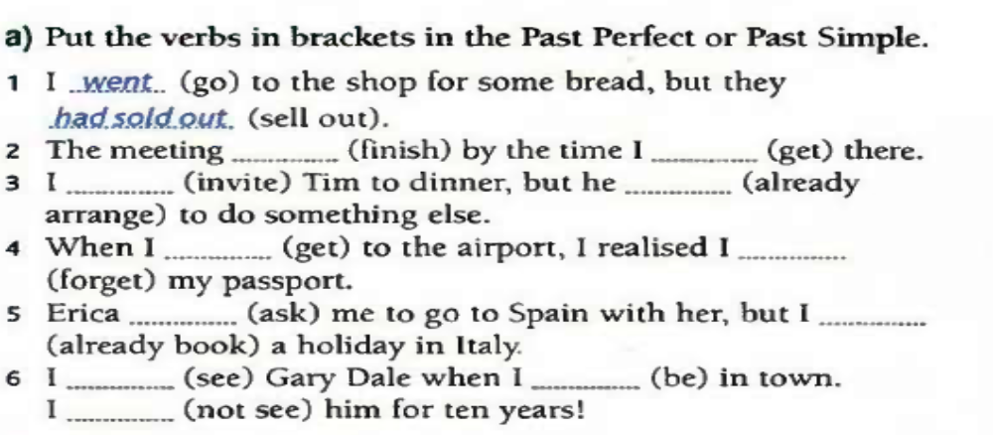

E. PUT THE VERBS IN BRACKETS IN THE PAST SIMPLE, PAST PERFECT OR PAST CONTINUOUS:

1. She ....................... (tell) us that she ....................... (already, be) to Paris.
2. By the time we ....................... (reach) the station the train ....................... (leave).
3. The little boy ....................... (refuse) to admit that he ....................... (eat) the chocolate.
4. Brian and Teresa ....................... (know) each other for ten years before they ....................... (get) married.
5. Although the rock band U2 ....................... (perform) occasionally before small audiences in the late 70s, their major hit ....................... (not, arrive) until the 80s.
6. When the teacher ....................... (arrive), they ....................... (play) in the back of the classroom.
7. She ....................... (walk) down the street when she ....................... (trip) on the pavement.
8. We ....................... (walk) in the mountains when we ....................... (hear) a piercing scream.
9. They ....................... (have) so much fun at the party, so they ....................... (decide) to stay.
10. I ....................... (drive) my new car when I ....................... (have) the accident.

PAST TENSES – REVISION (KEY)

ex. A.

1. He left at 3 o'clock.
Did he leave at 3 o'clock.?
He didn’t leave at 3 o'clock.
When did he leave?

2. I bought this dress in a big store.
DID I BUY THIS DRESS IN A BIG STORE/DID YOU BUY THIS DRESS IN A BIG STORE?
I/YOU DID NOT BUY THIS DRESS IN A BIG STORE.
WHAT DID YOU BUY IN A BIG STORE?

3. They went to the seaside last month.
DID THEY GO TO THE SEASIDE LAST MONTH?
THEY DIDN’T GO TO THE SEASIDE LAST MONTH.
WHERE DID THEY GO LAST MONTH?

4. She travelled alone in 1982.
DID SHE TRAVEL ALONE IN 1982?
SHE DIDN’T TRAVEL ALONE IN 1982.
HOW DID SHE TRAVEL IN 1982?

5. They came at seven o'clock.
DID THEY COME?
THEY DIDN’T COME.
WHEN DID THEY COME?

6. He heard the good news a minute ago.
DID HE HEAR THE GOOD NEWS?
HE DIDN’T HEAR THE GOOD NEWS.
WHAT DID HE HEAR A MINUTE AGO?

ex. B.

1. The sun WAS SHINING when I WENT OUT.
2. When mother ENTERED the room the children WERE SLEEPING.
3. I MET our teacher when I WAS GOING to town.
4. She WAS SITTING by the window when I PASSED BY by.
5. Mary WAS SITTINGat the table while her mother WAS PREPARING lunch.
6. This time yesterday I WAS PREPARING my lessons.
8. The teacher WAS READING the new lesson and the student WAS LISTENING TO him attentively.
8. - What WERE YOU DOING at 8 o'clock yesterday?
- I WAS HAVING breakfast.
9. I WAS DRIVING to the city centre when I SAW you.

ex. C.
1. She worked/was working quietly at her desk when suddenly the door opened/was opening and her daughter rushed/was rushing in.
2. I saw/was seeing you in the park yesterday. You sat/were sitting on a bench with your arm round Tom.
3. As soon as I walked/was walking into the room, he handed/was handing me the letter.
4. His father was really angry with him because he listened/was listening to music while he did/was doing his homework.
5. As he passed/was passing the bank, a man in a mask knocked/was knocking him onto the ground.
6. What did you write/were you writing when you computer crashed/was crashing?

ex. D.
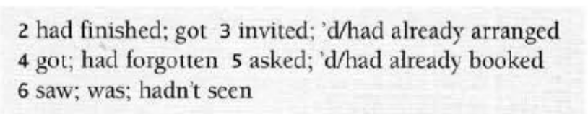

ex. E.

1. She TOLD us that she HAD ALREADY BEEN to Paris.
2. By the time we REACHED the station the train HAD LEFT
3. The little boy REFUSED to admit that he HAD EATEN the chocolate.
4. Brian and Teresa KNEW each other for ten years before they GOT MARRIED married.
5. Although the rock band U2 (HAD) PERFORMED occasionally before small audiences in the late 70s, their major hit DID NOT ARRIVE until the 80s.
6. When the teacher ARRIVED, they WERE PLAYING in the back of the classroom.
7. She WAS WALKING down the street when she TRIPPED on the pavement.
8. We WERE WALKING in the mountains when we HEARD a piercing scream.
9. They WERE HAVING so much fun at the party, so they DECIDED to stay.
10. I WAS DRIVING my new car when I HAD the accident.

THE FUTURE

1.1 FUTURE SIMPLE (BUDUĆI OBLIK/PROSTO BUDUĆE `VRIJEME`)
subjekat + pomoćni glagol will + infinitiv glavnog glagola
Odrične rečenice se prave umetanjem rječce not između pomoćnog i glavnog glagola, a upitne rečenice inverzijom subjekta i pomoćnog glagola.
U prvom licu jednine i množine umjesto glagola will, može se koristiti glagol shall, međutim u modernom engleskom will se više koristi od shall:
I shall call - we shall call (Ja ću zvati - Mi ćemo zvati).
Prosto buduće vrijeme se upotrebljava da bi označila radnja koja će se desiti u budućnosti.
Prosto buduće vrijeme se naročito često upotrebljava poslije glagola koji označavaju očekivanje, nadu itd.
I hope we will have better luck next day. (Nadam se da ćemo imati više sreće drugi put.)
We expect that he will come tomorrow. (Očekujemo da će on doći sjutra.)
to call – zvati
potvrdan oblik odričan oblik upitan oblik (YES/NO questions)
I will call (ja ću zvati) | I will not call | will I call?
you will call | you will not call | will you call?
he, she, it will call | he, she, it will not call | will he, she, it call?
we will call | we will not call | will we call?
you will call | you will not call | will you call?
they will call | they will not call | will they call?

Prosto buduće vrijeme se koristi:

- za izražavanje budućih radnji koje će se možda desiti:

We’ll visit Disney one day. (Posjetićimo Diznilend jednog dana.)

- da bi se izrazila prijetnja ili obećanje:

Stop or I will shot! (Stoj ili pucam!)
I will call you when I get there.(Pozvaću te kad stignem tamo.)

- da bi se izrazila namjera ili odluka donešena u trenutku govorenja:

My bags are heavy! I’ll help you. (ja sam se u tom trenutku,
bez prethodnog razmišljanja ponudio da pomognem)
The garden is very untidy. We’ll cut the grass.
- iza glagola think, hope, believe, expect i sl. i izraza I’m sure, I’m afraid kao i sa prilozima probably, perhaps i sl.

They’ll probably go to work.
I’m sure you will pass the test.

Izraze:

- Will you…? koristimo kada molimo nekog da uradi nešto za nas:
Will you post this letters instead of me, please? (Da li bi ga poslao ova pisma umjesto mene, molim te?)
- Shall I…? kada želimo da ponudimo da uradimo nešto za nekoga:
Shall I help you clean the garage? (Da li želiš da ti pomognem u čišćenju garaže?)

Buduće prosto vrijeme ne koristimo u zavisnim klauzama iza while, before, until, as soon as, after, if ili when. U ovim klauzama se u klauzi koja počinje veznicima i prilozima while, before, as soon as - javlja Simple Present Tense.
I’ll make a phone call while I wait for you. (ne: while I will wait for you)
We will go to school when we are five years old.
I will invite her as soon as she comes.
I won’t do anything until you are ready.

1.2 BE GOING TO, SIMPLE PRESENT AND PRESENT CONTINUOUS

Budućnost se kao što je već rečeno može izraziti i glagolskim oblicima koji mogu u svojim pomjerenim značenjima da izraze budućnost, a to su: prost prezent, preterit, sadašnji perfekt, prošli perfekat, sadašnji progresiv i sadašnji perfektivni progresiv. U ovom poglavlju osvrnućemo se na polumodal be going to kojim se takođe izražava budućnost, kao i dva glagolska oblika: prezent (Simple Present) i sadašnji progresiv (Present Continuous).

1.2.1 BE GOING TO

Polumodal be going to, koji nije sinhronijski vezan za glagol go, upotrebljava se uglavnom u neformalnom stilu i ima dvije buduće implikacije:

a) Može da znači da govornik misli na radnju koja predstavlja sigurnost govornika u buduće ispunjenje sadašnje namjere, što je najčistija budućnost koja zavisi od nečije volje. Ovaj oblik se upotrebljava češće nego budući oblik, kada je značenje namjere u pitanju, kada spremnost pređe u namjeru.

She is going to be a nurse when she grows up. (Ona će biti medicinska sestra kada odraste; to je njena namjera, i ovom rečenicom govornik iskazuje sigurnost da će se to i ostvariti jednog dana, u ovom slučaju kada ona odraste)

Bob is going to drive to London tommorow morning. (bliska budućnost, namjera)

b) Isto tako, oblik be going to može da izrazi vjerovatan budući rezultat sadašnjeg uzroka, i njime se tada izražava bliska budućnost.

Look at the clouds. It is going to rain. (Pogledaj te oblake. Padaće kiša; govornik iskazuje vjerovatan budući rezultat na osnovu nekog indikatora u sadašnjosti)
You look pale. You are going to faint. (Blijeda si. Onesvijestićeš se.)
to call – zvati
potvrdan oblik odričan oblik upitan oblik (YES/NO questions)
I am going to call (ja ću zvati) | I am not going to call | Am I going to call?
you are going to call | you aren’t going to call | Are you going to call?
he, she, it is going to call | he, she, it isn’t going to call | Is he, she, it going to call?
we are going to call | we aren’t going to call | Are we going to call?
you are going to call | you aren’t going to call | Are you going to call?
they are going to call | they aren’t going to call | Are they going to call?

N.B. OBLIK GOING TO SE UVIJEK KORISTI UZ GLAGOL TO BE (oblike AM, IS, ARE za budućnost)!!! BEZ GLAGOLA TO BE OBLIK GOING TO JE NEGRAMATIČAN.

I going to do that tomorrow. (netačno)
I am going to do that tomorrow. (tačno)

1.2.2 SIMPLE PRESENT AND PRESENT CONTINUOUS

PROST PREZENT (Simple Present Tense) je oblik koji se, posle oblika za budućnost will + infinitiv, najčešće koristi kada se govori o budućnosti. Javlja se u ovom značenju u IF-klauzama i WHEN-klauzama (vidi str. 36). Ako se javlja u glavnim klauzama, onda ima značenje sigurnosti, kao što su tvrdnje u vezi sa kalendarom, redom vožnje ili u opisima dogadjaja koji se ne mijenjaju. Upotrebljava se sa dinamičnim glagolima koji imaju značenje plana, sa kojima predstavlja nešto što se uzima kao normalno (npr: Tommorrow is Sunday. What time does the match begin?). Naime, budući prezent ne izražava mogućnost, već sigurnu budućnost.

What will you say, if I marry the boss? (Šta ćeš da kažeš ako se udam za šefa?)
The plane takes off at 2.30. (Avion polijeće u 2.30)
School recommences on January 12. (Škola ponovo počinje 14. januara.)

SADAŠNJI PROGRESIV (Present Continuous) se odnosi na budući događaj koji se očekuje u sadašnjosti i kao i sve progresivne forme u značenju budućnosti izražava predviđanje koje proizilazi iz sadašnjih planova ili dogovora. Present Continuous Tense sa budućim značenjem može takođe da znači da su budući događaji neminovost. Obično se Present Continuous koristi za radnju koja je isplanirana a desiće se u bliskoj budućnosti.
They are leaving for Mexico tommorrow.
(Oni odlaze za Meksiko sjutra; to je njihov plan, već su sve dogovorili i sjutra sigurno putuju)
They are seeing their doctor on Wednesday.
We are having supper with the Smiths next Sunday.
Glagoli see, have, move, go, meet su glagoli koji se najčešće upotrebljavaju u obliku Present Continuous sa značenjem dogovora u budućnosti.

REZIME:
% vjerovatnoća da će se radnja ostvariti  (prije nego govornik izgovori rečenicu) |  | oblik | koristi se za: | primjer
 | 0% | will + infinitiv | odluke u  trenutku  govorenja | Don't get up. I'll answer the phone.
 | 75% | `be going to` | namjere,  dokaz | We're going to watch TV tonight.  Look at the clouds. It is going to rain.
 | 90% | Present  Continuous | utvrđene  planove | I'm taking my exam in June.
 | 99.999% | Simple Present | red vožnje,  kalendar,  raspored časova | My plane takes off at 6.00am.

A. PUT THE VERBS IN BRACKETS INTO THE APPROPRIATE FUTURE FORM (WILL, GOING TO, PRESENT CONTINUOUS OR PRESENT SIMPLE)

1. I ……………………………………… (probably, phone) you on Friday.
2. Look at that tree. It ……………………………………… (fall down).
3. I`m sure he ……………………………………… (buy) me something.
4. We ……………………………………… (go) on holiday next week.
5. The train ……………………………………… (arrive) in half an hour.
6. She studies medicine. She ……………………………………… (be) a doctor one day.
7. .She is waiting for him to call her. I don’t think he ……………………………………… (call) her.
8. We ……………………………… (have) dinner with the Smiths tomorrow.
9. This class ……………………………… (start) at 10 not 11, young lady!
10. I bought a house. I ……………………………… (spend) my holidays there.

KEY:

ex. A.
1. I WILL PROBABLY PHONE you on Friday.
2. Look at that tree. It IS GOING TO FALL DOWN.
3. I`m sure he WILL BUY me something.
4. We ARE GOING on holiday next week.
5. The train ARRIVES in half an hour.
6. She studies medicine. She IS GOING TO BE a doctor one day.
7. .She is waiting for him to call her. I don’t think he WILL CALL her.
8. We ARE HAVING dinner with the Smiths tomorrow.
9. This class STARTS at 10 not 11, young lady!
10. I bought a house. I AM GOING TO SPEND) my holidays there.

THE FUTURE – REVISION

A. Fill in the gaps using will, be going to, the Present Simple or the Present Continuous Tense.

1. My cousins …………………………… (come) to dinner tomorrow.
2. She has bought a lot of food. She …………………………… (prepare) a delicious lunch today.
3. I am sure she …………………………… (call) you these days.
4. A: “Where are you going tomorrow?”
B: “I ………………………………………………………… (travel) to the seaside.”
5. Why are you taking that big basket? I …………………………… (buy) a lot of vegetables.
6. There’s somebody on the door! Ok, I …………………………… (go) and check who it is.
- My father ………………………… (take) my mother to a fancy restaurant tonight.
8. Oh, no! I forgot to post this letter. Don’t worry. I ………………………… (post) it for you.
9. I think that you can’t do it by yourself. I ………….………………… (help) you finish it.
- The train …………………………… (leave) at 7.
11. I don’t think he …………………………… (manage) to do it today.
- She looks wonderful. She …………..………………… (have) dinner with her boyfriend tonight.
- We …………………………… (move) in next week.
- We …………………………… (have) a party next Saturday.
15. “Why are you putting your old clothes on?”
“Because I …………………………………… (cut) the grass.
- The lecture …………………………… (start) at 11 young lady!
- She is waiting for him to call her. I don’t think he ……….…………………… (call) her.
- “He has just been taken to hospital with a broken leg.”
“I’m sorry to hear that. I ………………..……………… (send) him some grapes.
- “Why do you have so much food?”
“Because I …………………………… (cook) a meal for ten people.”
- “I passed my driving test!”
“That’s great! I …………………….…………… (buy) some champagne to celebrate!”
- I …………………………… (meet) with my business partners tonight.”
- “Oh, dear. I’m late for work.”
“Don’t worry. I …………………………… (give) you a lift.
- Look at her sad face! She …………………………… (cry).
24. “It’s Tony’s birthday next week.”
“Is it? I didn’t know. I …………………………… (send) him a card.
25. I …………………………… (go) out with my friends next week.
26. She has studied a lot. She ………………………………………….. (pass) an exam.
27. Plane …………………………… (take off) at 11:35.
28. Look at that tree! It …………………….……………… (fall) down.
29. I …………………………… (have) lunch with the president today.
30. We are sure he …………………………… (succeed) one day.

THE FUTURE – REVISION (KEY)

ex. A.

1. My cousins ARE COMING to dinner tomorrow.
2. She has bought a lot of food. She IS GOING TO PREPARE a delicious lunch today.
3. I am sure she WILL CALL you these days.
4. A: “Where are you going tomorrow?”
B: “I AM TRAVELLING to the seaside.”
5. Why are you taking that big basket? I AM GOING TO BUY a lot of vegetables.
6. There’s somebody on the door! Ok, I WILL GO and check who it is.
- My father IS TAKING my mother to a fancy restaurant tonight.
8. Oh, no! I forgot to post this letter. Don’t worry. I WILL POST it for you.
9. I think that you can’t do it by yourself. I WILL HELP you finish it.
- The train LEAVES at 7.
11. I don’t think he WILL MANAGE to do it today.
- She looks wonderful. She IS HAVING dinner with her boyfriend tonight.
- We ARE MOVING in next week.
- We ARE HAVING a party next Saturday.
15. “Why are you putting your old clothes on?”
“Because I AM GOING TO CUT the grass.
- The lecture STARTS at 11 young lady!
- She is waiting for him to call her. I don’t think he WILL CALL her.
- “He has just been taken to hospital with a broken leg.”
“I’m sorry to hear that. I WILL SEND him some grapes.
- “Why do you have so much food?”
“Because I AM GOING TO COOK a meal for ten people.”
- “I passed my driving test!”
“That’s great! I WILL BUY some champagne to celebrate!”
- I AM MEETING with my business partners tonight.”
- “Oh, dear. I’m late for work.”
“Don’t worry. I WILL GIVE you a lift.
- Look at her sad face! She IS GOING TO CRY.
24. “It’s Tony’s birthday next week.”
“Is it? I didn’t know. I WILL SEND him a card.
25. I AM GOING out with my friends next week.
26. She has studied a lot. She IS GOING TO PASS an exam.
27. Plane TAKES OFF at 11:35.
28. Look at that tree! It IS GOING TO FALL down.
29. I AM HAVING lunch with the president today.
30. We are sure he WILL SUCCEED one day.

INFINITIVE vs. GERUND

INFINITIV

Infinitiv je forma koja je jednaka osnovi glagola, i ovaj oblik predstavlja glagol kao riječ (leksemu) u rječniku i nema kategorije lica i vremena, kao ni kategorije gramatičkog broja i roda. U engleskom jeziku razlikujemo dva oblika sadašnjeg infinitiva:
a. to-infinitiv e.g. to play, to cry, to love etc.
b. krnji infinitiv (bez “to”) play, cry, love etc.

Infinitiv koristimo:

a) iza sljedećih glagola: b ) posle izraza:
I would like
I would love
I would prefer

advise | agree | choose | decide
ask | beg | tell | invite
expect | hope | offer | promise
plan | refuse | seem | want

I plan to leave. I would love to help you.
She asked him to stay. He learned to drive. They would like to see you.

Iza modalnih glagola (can, must, should.) koristimo krnji infinitiv. e.g. You must leave.

Iza glagola let and make takođe koristimo krnji infinitiv (bez to!) e.g. She made me call him. Let her go out.

GERUND

Gerund je oblik glagola sa sufiksom -ing (fishing, riding, stopping).

Gerund koristimo:

a) iza sljedećih glagola: b) iza predloga (AT, IN, ON, OF, ABOUT, AFTER, BY) :
I am interested in fishing.
She is good at swimming.
admit | avoid | give up | keep
go | confess | risk | finish
like | love | hate | enjoy
prefer | deny | finish | postpone
c) iza izraza: be busy, it’s no use, it’s not worth
He is busy preparing the exam.
d) iza izraza: look forward to
I look forward to seeing you
I look forward to meeting them.

I prefer/love staying home. e) iza izraza: Would you mind…
Joanna gave up smoking. Would you mind closing the door?

INFINITIVE vs. GERUND - EXERCISES

A. PUT THE VERBS IN BRACKETS INTO THE CORRECT INFINITIVE FORM OR THE –ING FORM:

- I would like …………………… (go out) tonight.
- She hates …………………… (play) cards.
- I can’t make a decision. I keep …………………… (change) my mind.
- He had made his decision and refused …………………… (change) his mind.
- It was a really good holiday. I really enjoyed …………………… (be) by the sea again.
- I look forward…………………… (hear) from you.
- They are bad at …………………… (write) essays.
- Let us …………………… (go) to the theatre tonight.
- He is going to ask Ivy …………………… (marry) him.
- I made him …………………… (promise) that he wouldn’t tell anybody.
- My father didn’t allow me…………………… (take) his new car.
- Are you looking forward …………………… (go) on holiday?
- Actually I wanted …………………… (ask) you to give me a call when you finish .
- He admitted …………………… (steal) the jewelry.
- How about …………………… (meet) for lunch tomorrow?
- She was interested in ……………………………….. (ski).
- Thanks very much for …………………… (invite) me to your party.
- I’d like …………………… (visit) Ireland.
- Would you mind …………………… (close) the window? It is rather chilly.
- He wouldn’t let me…………………… (read) the letter.
- It’s no use…………………… (tell) her the truth.
- You must be fed up with …………………… (learn) English.

INFINITIVE vs. GERUND – EXERCISES (KEY)

ex. A.

- I would like TO GO OUT tonight.
- She hates PLAYING cards.
- I can’t make a decision. I keep CHANGING my mind.
- He had made his decision and refused TO CHANGE his mind.
- It was a really good holiday. I really enjoyed BEING by the sea again.
- I look forward TO HEARING from you.
- They are bad at WRITING essays. (iza predloga koristimo gerund!)
- Let us GO to the theatre tonight.
- He is going to ask Ivy TO MARRY him.
- I made him PROMISE that he wouldn’t tell anybody.
- My father didn’t allow me TO TAKE his new car.
- Are you looking forward TO GOING on holiday?
- Actually I wanted TO ASK you to give me a call when you finish .
- He admitted STEALING the jewelry.
- How about MEETING for lunch tomorrow? (iza predloga koristimo gerund!)
- She was interested in SKIING.
- Thanks very much for INVITING me to your party.
- I’d like TO VISIT Ireland.
- Would you mind CLOSING the window? It is rather chilly.
- He wouldn’t let me READ the letter.
- It’s no use TELLING her the truth.
- You must be fed up with LEARNING English.

KONDICIONALI

1.1 Zero Conditional – Nulti kondicional

Forma:

If rečenica + glavna rečenica

U If rečenici koristimo Present Simple Tense kao i u glavnoj rečenici, zato što ovim kondicionalom izražavamo nešto što je univerzalna istina. Ovaj kondicional se i zove Nulti zato što na engleskom Condition znači uslov, dakle on izražava nulti uslov ili nepostojanje bilo kakvog uslova za njegovu realizaciju. Dakle, s obzirom da izražava univerzalnu istinu, ne postoji nikakav uslov za njegovo izvršenje.

IF CLAUSE | MAIN CLAUSE
PRESENT SIMPLE | PRESENT SIMPLE

If you drop an egg, it breaks. Ako ispustiš jaje, ono će se slomiti.
If you boil water, it evapourates. Ako kuvaš vodu, ona isparava.
If you have a headache, take an aspirin. Ako te boli glava, uzmi aspirin.

1.2 First conditional – Prvi Kondicional - realni

Ovaj kondicional je realan, jer izražava uslov koji je realan. Npr. Za mene je realno da ću sjutra izaći u grad sa prijateljima, pa formiram rečenicu I kondicionala:

If I go out tomorrow, I will meet my friends.
Ako izađem sjutra, srešću svoje prijatelje.

IF CLAUSE | MAIN CLAUSE
PRESENT SIMPLE | FUTURE SIMPLE  (will + infinitive)

Dakle u If - rečenici koristimo Present Simple Tense, a u glavnoj rečenici Future Simple. S obzirom da se opet govori o nečemu što je prilično realno i činjenično, opet koristimo Present Simple Tense u glavnoj rečenici. Ali, ovdje za razliku od Nultog kondicionala, ipak postoji neka vrsta uslovljenosti i veća doza neizvjesnosti da li će se radnja izvršiti. Mada je njeno izvršenje veoma realno, jer je uslov takođe realan.

If he studies hard, he will pass an exam.
Ako puno uči, položiće ispit. – dakle, on uči dosta i sigurno će položiti ispit.

If I send her a letter, she will be really happy.
Ako joj pošaljem pismo, biće veoma srećna. – Dakle, ja planiram da joj pošaljem pismo.

1.3. VREMENSKE REČENICE

Vremenske rečenice su rečenice koje se, kao i uslovne rečenice, sastoje od glavne, nezavisne klauze i zavisne klauze (koja ne može da stoji nezavisno od glavne rečenice). Zavisna rečenica/klauza počinje veznicima BEFORE, AFTER, WHEN, AS SOON AS, UNTIL i sl.

VREMENSKA KLAUZA  (klauza koja počinje veznicima i prilozima WHEN, AFTER, BEFORE, AS SOON AS, UNTIL …) | MAIN CLAUSE
PRESENT SIMPLE | FUTURE SIMPLE  (will + infinitive)

I will give them a ring BEFORE they go on holiday.
I will believe it WHEN I see it.
UNTIL I decide what to do, I won’t tell them.

CONDITIONAL CLAUSES - REVISION

A. FILL IN THE GAPS WITH THE CORRECT FORM OF THE VERBS IN BRACKETS.
- If you eat too much, you _______________ (be) ill.
- You will pass your examination if you ______________ (work) hard.
- You ______________ (catch) the train if you ______________ (leave) earlier. There's still chance to catch it.
- Before she ______________ (do) a degree, she will have to pass all her exams.
- If you ______________ (not water) the plants, they often ______________ (die).
- If water _________________ (freeze), it ________________ (turn) to ice.
- When he ________________ (make) progress, he will be able to leave.
- After I _____________________ (meet) my friend, I _________________ (ask) him to come round.
- If you ___________________ (touch) fire, you __________________ (get) burnt.
- If you send her a bunch of flowers she _______________ (be) very happy.

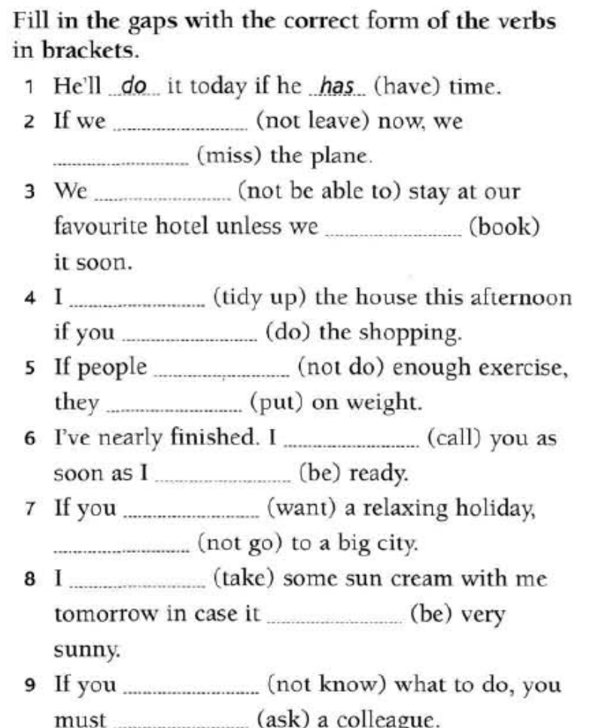

CONDITIONAL CLAUSES - REVISION (KEY)

ex. A.
- If you eat too much, you WILL BE ill.
- You will pass your examination if you WORK hard.
- You WILL CATCH the train if you LEAVE earlier. There's still chance to catch it.
- Before she DOES a degree, she will have to pass all her exams.
- If you DON'T WATER the plants, they often DIE.
- If water FREEZES, it TURNS to ice.
- When he MAKES progress, he will be able to leave.
- After I MEET my friend, I WILL ASK him to come round.
- If you TOUCH fire, you GET burnt.
- If you send her a bunch of flowers she WILL BE very happy.

ex. B.
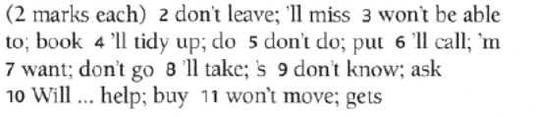

DODATNA GRAMATIČKA OBJAŠNJENJA

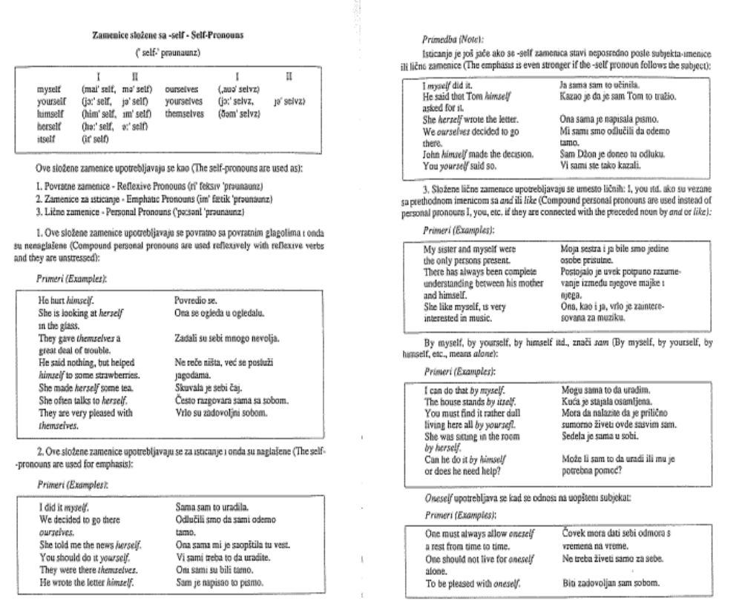

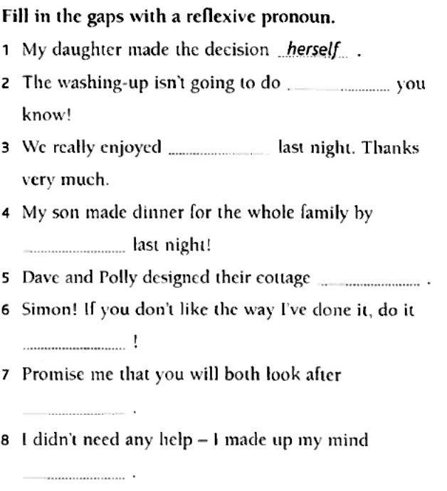
KEY:
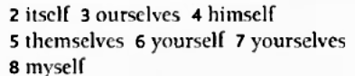

ADJECTIVES (PRIDJEVI)

Pridjev je u engleskom jeziku nepromjenljiva riječ, pa se prema tome pridjevom ne može izraziti ni rod, ni broj ni padež. Pridjev obično stoji ispred imenice.

Comparasion (Poređenje pridjeva)

Pridjevi imaju tri stupnja poređenja:

prvi stupanj - jednakost - positive
drugi stupanj - nejednakost - comparative
treći stupanj - nadmoćnost - superlative.

Jednakost se izražava pomoću riječi "as...as" i pozitiva pridjeva.

He is as rich as his friend. (On je isto toliko bogat kao njegov prijatelj).

Komparativ, kojim se izražava umanjenost, obrazuje se pomoću riječi "less...then":

He is less rich than his brother. (On je manje bogat od svog brata)

Komparativom se izražava uvećanost, i obrazuje se:

- kod jednosložnih i nekih dvosložnih pridjeva dodavanjem nastavka "er":

He is richer than his friend. (On je bogatiji od svog brata);

- kod višesložnih pridjeva dodavanjem nastavka "more" ispred pridjeva:

He is more independent than his brother. (On je samostalniji od svog brata);

Treći stupanj superlativ može biti:

- relativni, kada je poređenje izraženo pridjevom na najvišem ili najnižem stepenu.

On se pravi kod:

- jednosložnih i nekih dvosložnih pridjeva dodavanjem člana the i nastavka "-est":
She is the richest (Ona je najbogatiji);

- višesložnih pridjeva dodavanjem "the most":
She is the most intelligent (Ona je najpametniji);

- Pravopisna pravila pri poređenju

Ako se pridjev završava kratkim samoglasnikom iza kojeg dolazi suglasnik, taj se suglasnik udvostručuje:
fat- fatter- the fattest (debeo),
big- bigger- the biggest (velik).

Ako se pridjev završava muklim "e", na komparativ i superlativ dodaju se nastavci "-r", odnosno "-st":
fine - finer- the finest (lijep).

Ako se pridjev završava slovom "y" ispred kojeg se nalazi suglasnik ono se mijenja u "i":
pretty- prettier- the prettiest (drag),
ali gray- grayer- the grayest (jer "y" dolazi poslije samoglasnika, a ne suglasnika).

Poređenje pridjeva pomoću nastavka "-er" za komparativ i "-est" za superlativ naziva se germansko poređenje. Na ovaj način porede se svi jednosložni predjevi - sa izuzetkom sljedećih:
just (more just, the more just); right (more right, the most right)
Germanskim načinom poređenja porede se još i dvosložni pridjevi koji se završavaju na "-y", "-ow",
"-er" ili na silabično "l", kao i pridjevi koji imaju naglasak na drugom slogu:

pretty, prettier, the prettiest;
narrow, narrower, the narrowest;
clever, cleverer, the cleverest
simple, simpler, the simplest;
polite, politer, the politest.

Poređenje koje se dobiva dodavanjem riječi "more" za komparativ i "the most" za superlativ ispred pridjeva naziva se romansko poređenje. Ovim načinom porede se svi višesložni pridjevi koji imaju naglasak na prvom slogu, kao i pridjevi koji se zavšavaju na "-ed" i "-ing":
famous, more famous, the most famous;
learned, more learned, the most learned;
beautiful, more beautiful, the most beautiful.
Mnogi dvosložni pridjevi mogu se porediti na oba načina. Takvi su pridjevi:
common, cruel, pleasant, quiet, cheerful, handsome…
Nepravilna komparacija pridjeva - Irregular comparasion

Positive
  Comparative
  Superlative
good (dobar) | better | the best
bad (loš)
evil (zao) | worse | the worst
ill (bolestan)
many (mnogo) | more | the most
little (malen) | less | the least
late (kasan) | later (kasniji) | the latest (najnoviji)
 | latter (dalji po redu) | the last (posljednji)
far (daleko) | farther (prostorno dalji) | the farthest
 | further (dalji po redu) | the furthest

Ex. A. Fill in the gaps with the comparative or superlative form of the adjectives in brackets:

- Which is ………………… (cold) planet in our solar system? Pluto.
- Which is ……………….. (heavy) animal in the world?
- Is the Mount Everest …………………. (high) than Kilimanjaro?
- Are women ……………. (shy) than men? And are they ………..…………..…. (just) and ……….…………. (right) than men?
- Has an eagle got …………………… (good) sight than humans?
- What is ………………………. (popular) sport in your country?
- Which are …………………… (hot) deserts in the world?
- Was Albert Einstein …………………… (intelligent) man of his time?
- Who is ………………………… (beautiful) – Angelina or Monica?
- He was a bit depressed yesterday, but today he looks ………………………. (happy).
- I prefer this chair to that one. It is ………………………. (comfortable).
- It was an awful day. It was ………………………. (bad) day of my life.
- The United States is very large but Canada is ………………………. (large).

KEY

Ex. A.

- Which is THE COLDEST planet in our solar system? Pluto.
- Which is THE HEAVIEST animal in the world?
- Is the Mount Everest HIGHER than Kilimanjaro?
- Are women SHYER than men? And are they MORE JUST and MORE RIGHT than men?
- Has an eagle got BETTER sight than humans?
- What is THE MOST POPULAR sport in your country?
- Which are THE HOTTEST deserts in the world?
- Was Albert Einstein THE MOST INTELLIGENT man of his time?
- Who is MORE BEAUTIFUL – Angelina or Monica?
- He was a bit depressed yesterday, but today he looks HAPPIER.
- I prefer this chair to that one. It is MORE COMFORTABLE.
- It was an awful day. It was THE WORST day of my life.
- The United States is very large but Canada is LARGER.

IDENTIFYING AND CORRECTING MISTAKES (ISPRAVLJANJE GREŠAKA)

A. IDENTIFY THE MISTAKES IN THE FOLLOWING SENTENCES AND CORRECT THEM. THE FIRST SENTENCE IS DONE FOR YOU.

INCORRECT: Do you watch TV in the evenings always?
CORRECT: Do you always watch TV in the evenings?

- When did you gone home?
…………………………………………………………………………………..
- Children tend being very noisy.
…………………………………………………………………………………..
- Why are you so unpatient?
…………………………………………………………………………………..
- They didn’t used to live in London.
…………………………………………………………………………………..
- I had a shower when the phone rang.
…………………………………………………………………………………..
- What do you do last night at eight?
…………………………………………………………………………………..
- While I was watching TV she ironed.
…………………………………………………………………………………..
- I tryed to help you but you didn’t listen.
…………………………………………………………………………………..
- Harriet was opening the door and walked into the house.
…………………………………………………………………………………..
- Brian drank tea at five o’clock yesterday afternoon.
…………………………………………………………………………………..
- The film is starting at 8 o’clock.
…………………………………………………………………………………..
- Wait here until he will come.
…………………………………………………………………………………..
- I haven’t maked any mistakes in this exercise.
…………………………………………………………………………………..
- She always does mistakes in her maths test.
…………………………………………………………………………………..
- Soap operas really take on my nerves.
…………………………………………………………………………………..
- Ross hasn’t got much confident.
…………………………………………………………………………………..
- I went to see my sister out at the station.
…………………………………………………………………………………..
- My girlfriend is very sensible, she gets embarrassed very easily.
…………………………………………………………………………………..
- The patient did a complete recovery.
…………………………………………………………………………………..

- I knew I seen her before.
…………………………………………………………………………………..
- I used to go to my sister’s wedding last year.
…………………………………………………………………………………..
- I have never travelled of my own.
…………………………………………………………………………………..
- She is a better swimmer then I.
…………………………………………………………………………………..
- I live in the ground floor.
…………………………………………………………………………………..
- The police let him to go home.
…………………………………………………………………………………..
- She is shier than me.
…………………………………………………………………………………..
- We watched the football alive.
…………………………………………………………………………………..
- Your room is a mess. You need to tidy all those things away.
…………………………………………………………………………………..
- Most belts are made of tin.
…………………………………………………………………………………..

IDENTIFYING AND CORRECTING MISTAKES (KEY)

Ex. A.

INCORRECT: Do you watch TV in the evenings always?
CORRECT: Do you always watch TV in the evenings?

- When did you gone home? go
- Children tend being very noisy. to be
- Why are you so unpatient? impatient
- They didn’t used to live in London. didn’t use
- I had a shower when the phone rang. was having
- What do you do last night at eight? were you doing
- While I was watching TV she ironed. was ironing
- I tryed to help you but you didn’t listen. tried
- Harriet was opening the door and walked into the house. opened
- Brian drank tea at five o’clock yesterday afternoon. was drinking
- The film is starting at 8 o’clock. starts
- Wait here until he will come. come
- I haven’t maked any mistakes in this exercise. made
- She always does mistakes in her maths test. makes
- Soap operas really take on my nerves. get
- Ross hasn’t got much confident. confidence
- I went to see my sister out at the station. off
- My girlfriend is very sensible, she gets embarrassed very easily. sensitive
- The patient did a complete recovery. made
- I knew I seen her before. saw/had seen
- I used to go to my sister’s wedding last year. went
- I have never travelled of my own. on
- She is a better swimmer then I. than
- I live in the ground floor. on
- The police let him to go home. go
- She is shier than me. shyer
- We watched the football alive. live
- Your room is a mess. You need to tidy all those things away. put
- Most belts are made of tin. leather

PART TWO – VOCABULARY

VOCABULARY - EXERCISES

A.

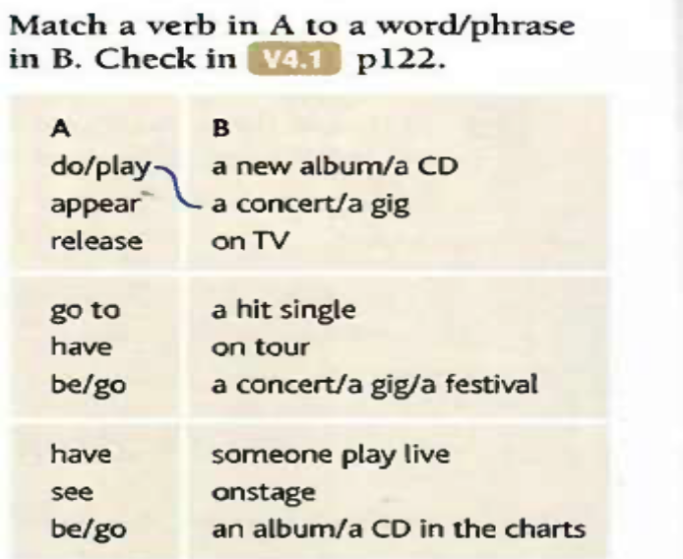

B.

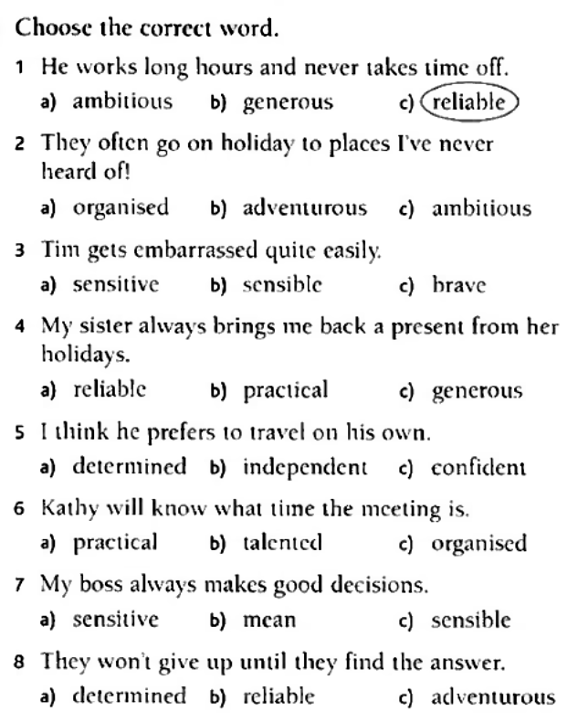

C.
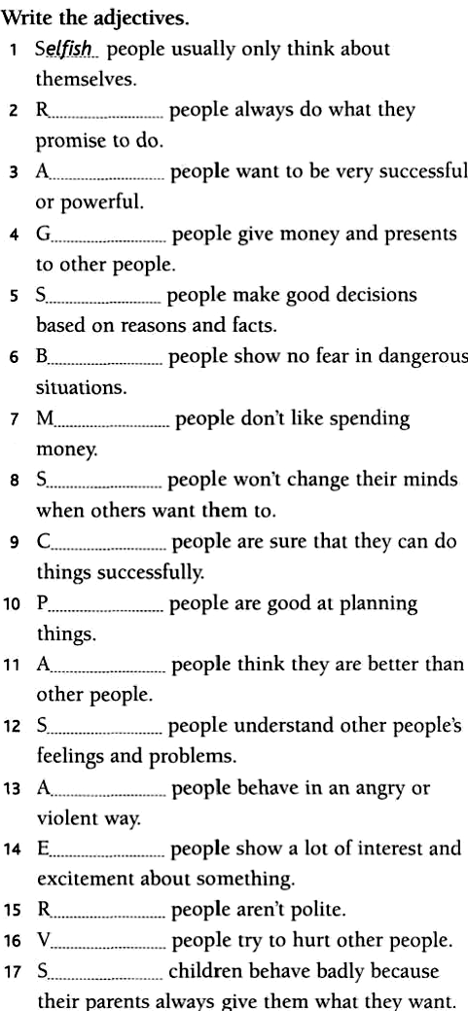

D. TRANSLATE THE FOLLOWING WORDS.

WORD | TRANSLATION EQUIVALENT(S)
a gig
release
remedy
treat
heal
determined
reliable
sensible
sensitive
stubborn
mean
generous
cure
recovery
sap

E. PUT THESE WORDS/PHRASES INTO GROUPS 1-3.

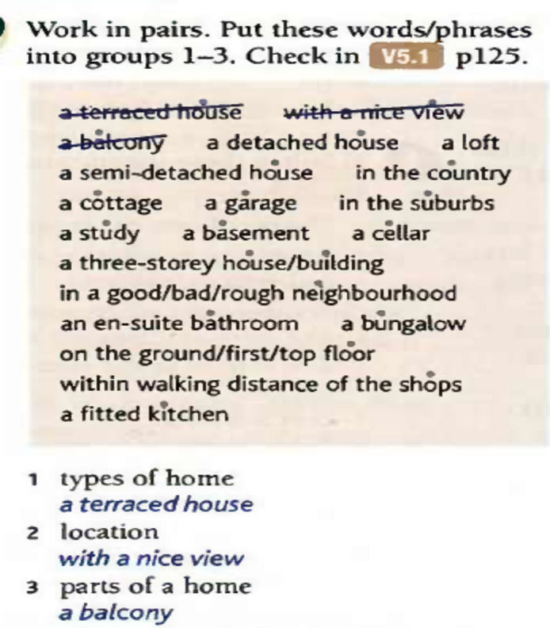

F.

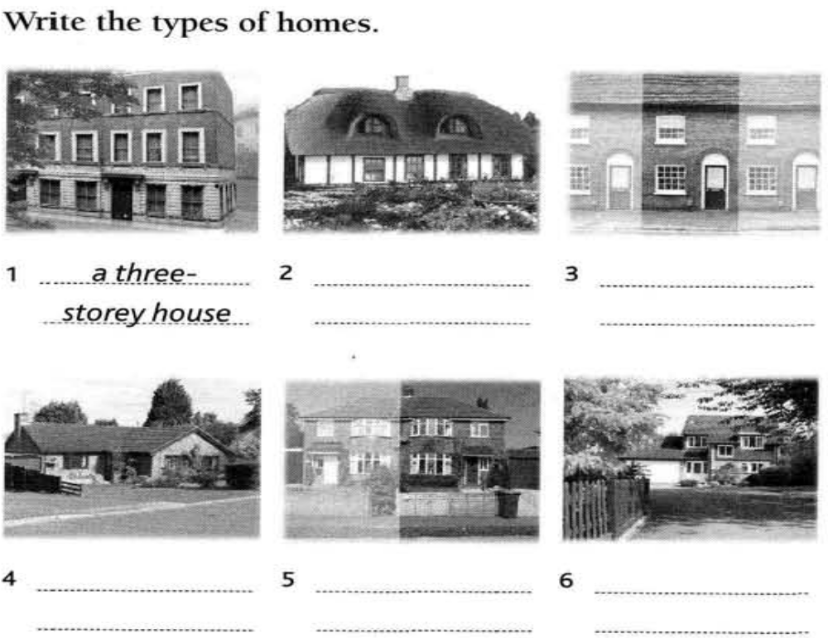

G.

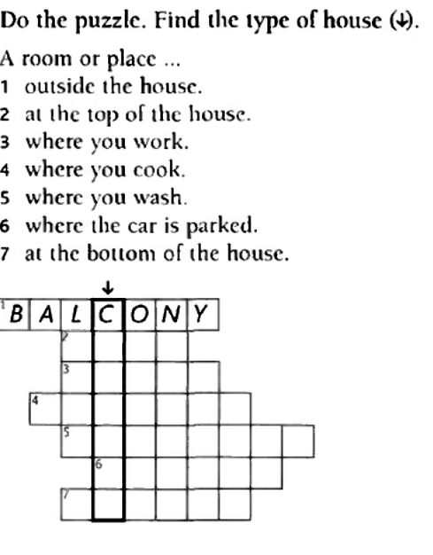

H.

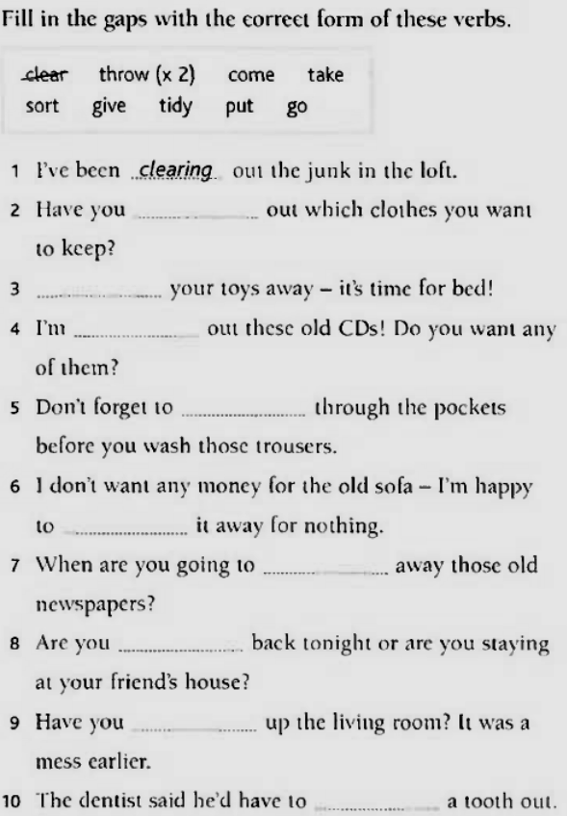

I.

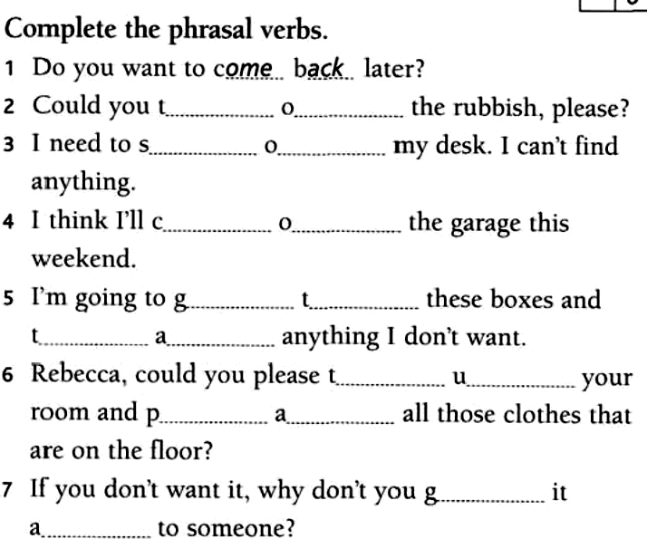

J.

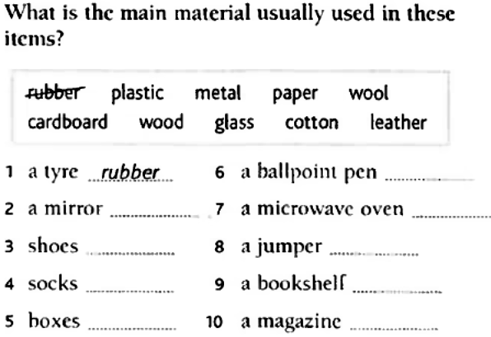

K. DO WE USE MAKE OR DO WITH THESE PHRASES?

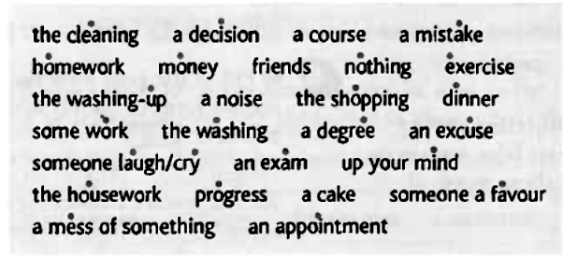

L.

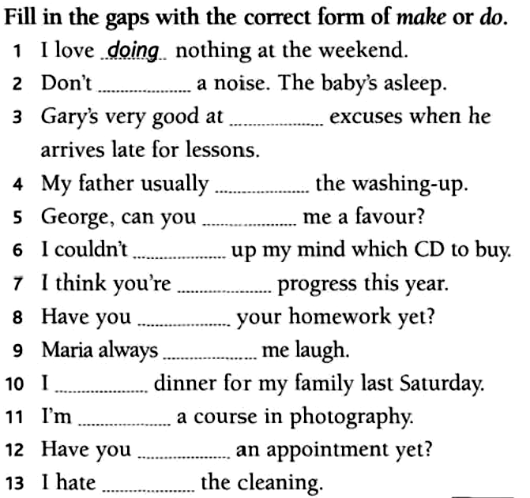

M. PROVIDE SYNONYMS FOR THE FOLLOWING WORS:
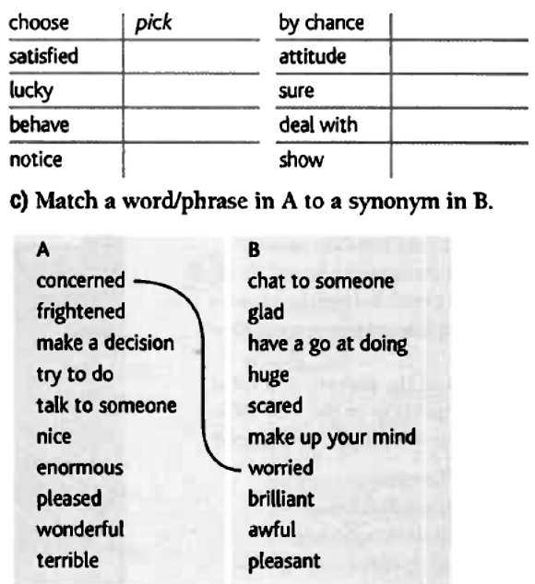

N.

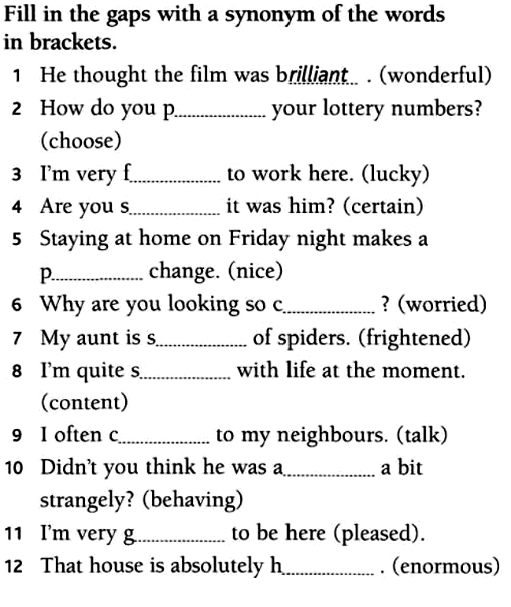

VOCABULARY – EXERCISES (KEY)

Ex. A.

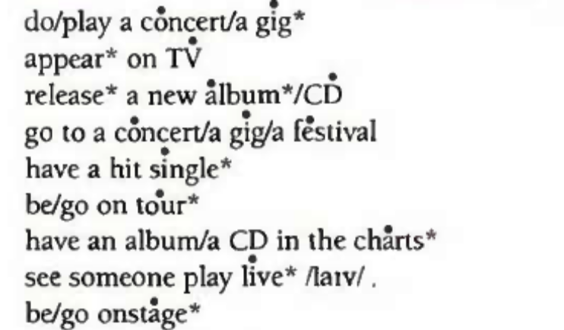

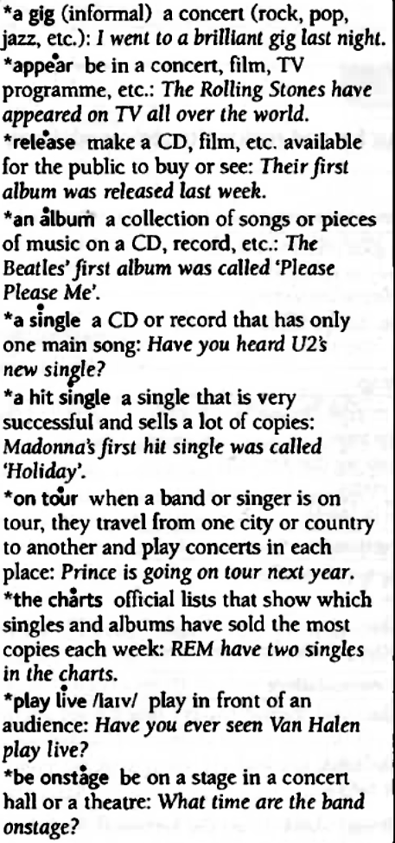

Ex. B.

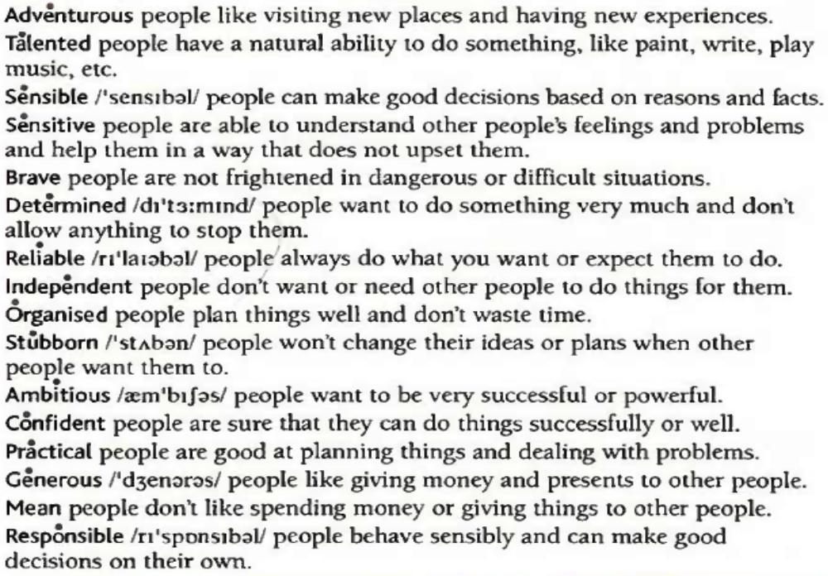

Ex. C.

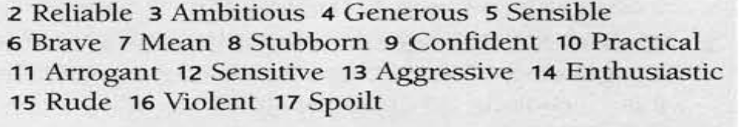

Ex. D.

WORD | TRANSLATION EQUIVALENT(S)
gig | svirka, tezga (muz.)
release | objaviti, iznijeti na tržište (launch)
remedy | lijek
treat | liječiti
heal | liječiti, zacijeliti, vidati
determined | odlučan
reliable | pouzdan
sensible | razuman, razborit
sensitive | osjetljiv, osjećajan
stubborn | tvrdoglav
mean | škrt, zao
generous | velikodušan, darežljiv, plemenit
cure | lijek
recovery | oporavak
sap | biljni sok, krepkost

Ex. E.
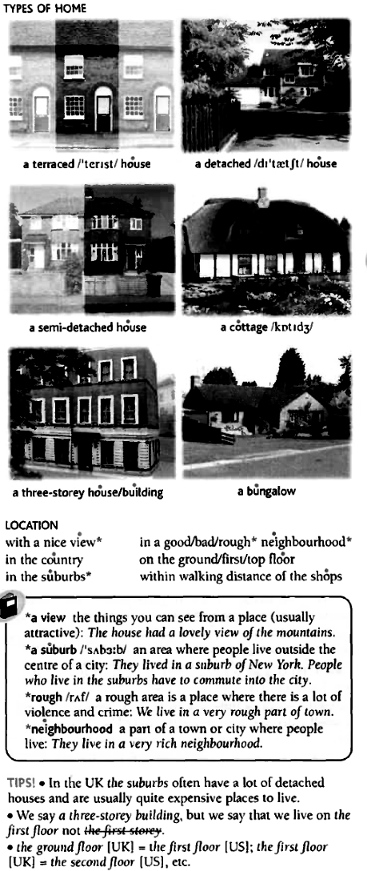

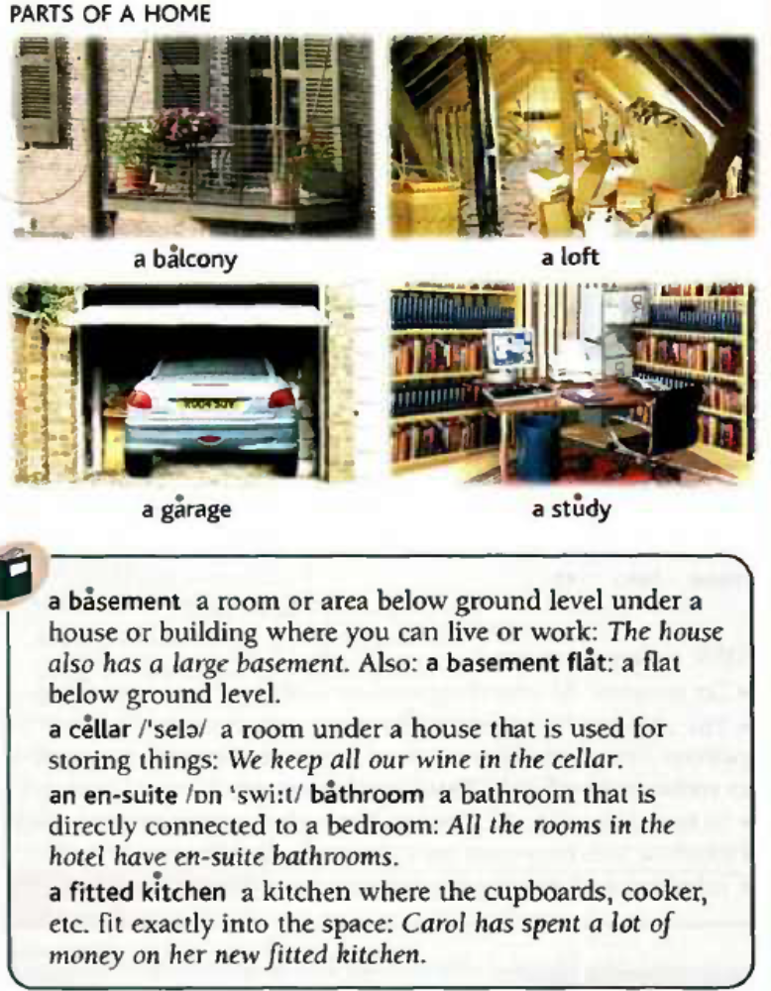

Ex. F.

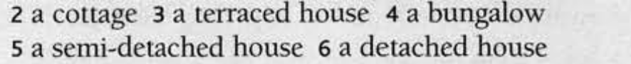

Ex. G.

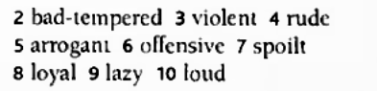

Ex. H.

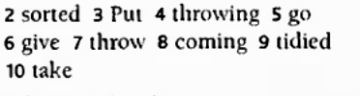

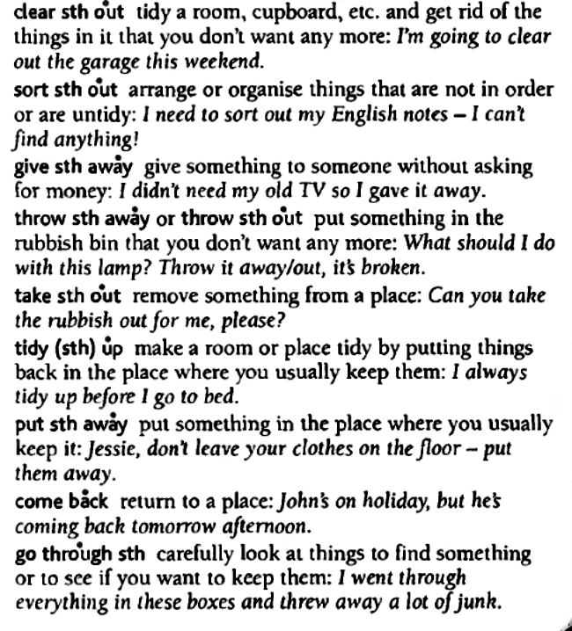

Ex. I.

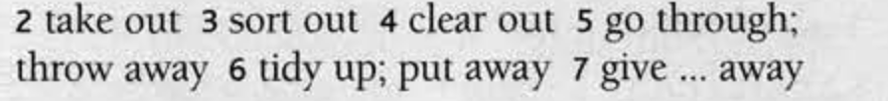

Ex. J.

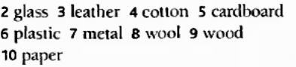

Ex. K.

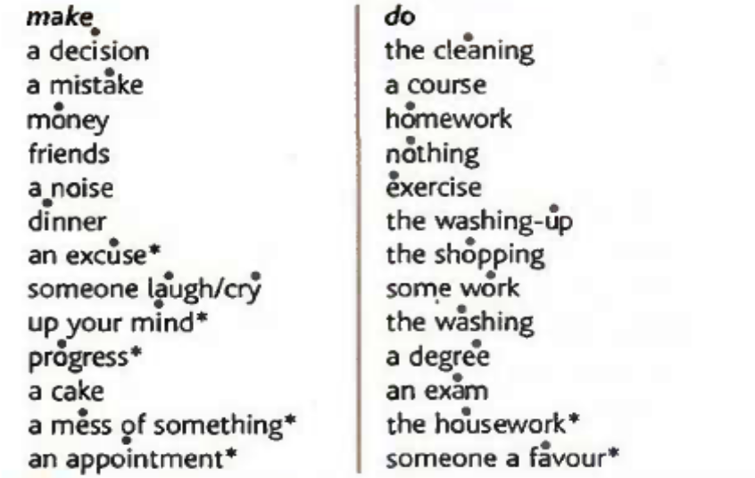

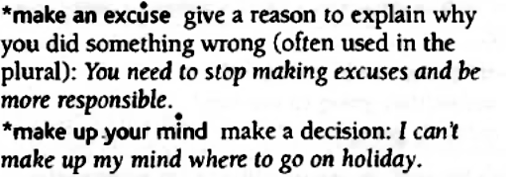

Ex. L.

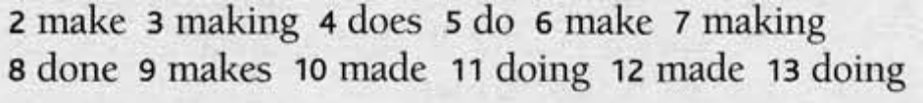

Ex. M.
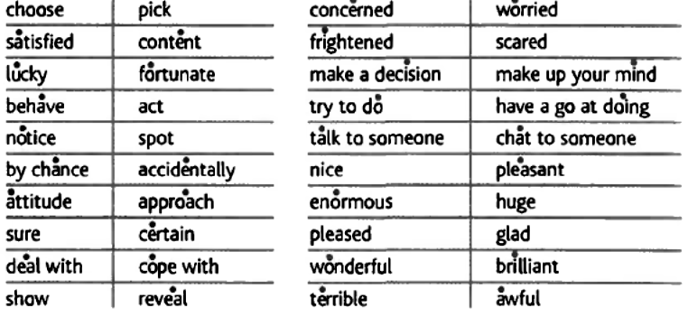

Ex. N.

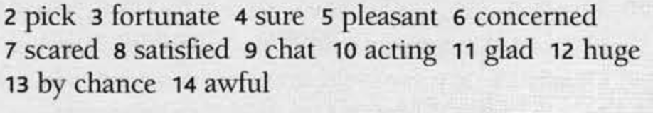

UNIVERSITY OF MONTENEGRO
50
FACULTY OF ECONOMICS
FINAL TEST
(mock test)

Name |  | Index no.
Teacher

A. READING COMPREHENSION

The era of mass tourism in the mountain regions of industrialized countries began soon after World War II. This new phenomenon was a result of many factors, including increases in urban populations, income, vacation time, and mobility.
Today, in the era of cheap, global air travel, almost no mountains in any corner of the world are out of reach. Moreover, `adventure tourists' and `eco-tourists' are willing to pay well, and their money is very welcome to poor governments and communities.
Although stories about the problems caused by tourism have become increasingly frequent in recent years, it is not necessarily a destructive force. The situation could be far better if tour operators and legislators considered how best to integrate tourism into the existing culture, with a minimal impact on the environment, and without host countries becoming too dependent on it. Merely restricting tourism cannot be the solution, because people's desire to see new places will not just disappear.
But the real key to the problem lies in giving indigenous communities greater control over the rate at which tourism grows, and the paths it takes. Encouragingly, more and more communities are demonstrating that, with firm decision-making, this is possible.

1. Are the following statements true (T) or false (F)?
a) There are still a lot of inaccessible areas in the mountains.
b) Some people are controlling the growth of tourism in their communities.

2. Choose a, b, or c, in each question below. Only one choice is correct.

1. Mass tourism in the mountains ...
a) was a result of World War II.
b) occurred partly because people had more money.
c) helped to improve income and mobility.

2. Nowadays, mountain communities ...
a) are happy to receive money from tourism.
b) see tourism as an impossible problem.
c) are willing to pay well to visit new destinations.

3. Tourism is not necessarily a problem if ...
a) it is integrated into the local culture.
b) it is not accepted by the community but integrated into culture.
c) it can be avoided, causing minimal impact on the environment.

4. According to the text, we need to ...
a) reduce people's desire to see new places.
b) restrict tourism in rural areas.
c) control the growth of tourism and how it develop

3. Find a word or phrase in the text which, in context, is similar in meaning to:
a) inexpensive ……………………………………..
6
b) limit ……………………………………..

B. READ THE TEXT BELOW AND DECIDE WHICH ANSWER (A, B, C or D) BEST FITS EACH SPACE.

Travelling to all (1) …………………………of the world gets easier and easier. We live in a (2) …………………………village, but how well do we know and understand (3) ………………………… other? Here is a (4) ………………………… test. Imagine you have arranged a meeting (5) ………………………… four o’clock. What time (6) ………………………… you expect your (7) ………………………… business colleagues to arrive?

1. A angle B corner C angles D corners
2. A international B global C globally D globe
3. A one B each C every D all the
4. A simply B simplified C simple D simplicity
5. A at B on C in D into
6. A will B are C are you able to D must
7. A stranger B alien C unknown D foreign

6
1. | 2. | 3. | 4. | 5. | 6. | 7.

C. COMPLETE THE SENTENCES USING PAST SIMPLE, PAST CONTINUOUS OR PAST PERFECT.

1. I ...................................... (drive) a car when I .................................... (run) into a lamp post.
2. When I arrived the house was empty. Everyone ........................................ (go out).
6
3. As soon as he saw the police, he ........................................ (run off).

D. PUT THE VERBS IN BRACKETS INTO THE APPROPRIATE FUTURE FORM (WILL, GOING TO, PRESENT CONTINUOUS OR PRESENT SIMPLE TENSE)

1. Ask John if you have any problems with your homework. I’m sure he ........................................(help) you.
2. Peter and Pat ..................................................... (come) for a meal tonight.
3. “Why are you making sandwiches? – Because we ........................................... (have) a picnic on the beach.
4. The train ..................................................... (leave) at 5.30 p.m.
8

E. PUT THE VERBS IN BRACKETS IN THE CORRECT FORM (GERUND OR INFINITIVE)

1. We were all too afraid to speak. Nobody wanted ........................................ (say) anything.
2. I enjoy........................................ (listen) to music.
3. He had made his decision and refused ........................................ (change) his mind.
4. She wanted me ........................................ (do) the cooking.
5. I adore ........................................ (read) good detective stories.
6
6. My parents let me ........................................ (do) what I wanted when I was young.

F. PUT THE VERBS IN BRACKETS INTO THE CORRECT FORM

1. If you ........................................ (not call) him now, he ........................................ (be) very angry.
2. As soon as demand ........................................ (increase), prices ........................................(rise).
3. If you ........................................ (cool) the liquid to 32 degrees, it ................................ (freeze).
6

G. FIND THE MISTAKES IN THE FOLLOWING SENTENCES AND CORRECT THEM

1. She is looking forward to see you.
.........................................................................................................................................................
2. Ann hasn’t got much confident.
.........................................................................................................................................................
3. My flat is as big than yours.
6
.........................................................................................................................................................

H. DECIDE WHICH OF THE WORDS BELOW FITS THE GAPS.

1. He usually ........................................ us laugh when we meet up with friends.
A takes B has C makes D gets
2. If you want to open a bottle of wine, you need a .........................................
A screwdriver B hammer C corkscrew D drill
3. If you buy ........................................ furniture, you will have to put it together.
A flatset B flatpack C flatsack D flatlack
4. Your room is a mess. You need to ........................................ it .........................................
A put out B throw out C clear out D throw away
5. After she has moved house, she has got a lot more ........................................ living room.
A space B spacious C spacy D spaced
6. Children tend to be ........................................ when they want to get a toy.
A unpatient B patient C impatient D impatience

6
1. | 2. | 3. | 4. | 5. | 6.

UNIVERSITY OF MONTENEGRO
FACULTY OF ECONOMICS
FINAL TEST (KEY)
(mock test)

Ex. A.

1. a) F b) T
2. 1. b) 2. a) 3. a) 4. c)
3. a) CHEAP
b) RESTRICT

Ex. B.

1. | 2. | 3. | 4. | 5. | 6. | 7.
B | B | B | C | A | A | D

Ex. C.

1. WAS DRIVING, RAN
2. HAD GONE OUT
3. RAN OFF

Ex. D.

1. WILL HELP
2. ARE COMING
3. ARE GOING TO HAVE
4. LEAVES

Ex. E.

1. TO SAY
2. LISTENING
3. TO CHANGE
4. TO DO
5. READING
6. DO

Ex. F.

1. DON’T CALL, WILL BE
2. INCREASES, WILL RISE
3. COOL, FREEYES

Ex. G.

- She is looking forward to see you. SEEING
- Ann hasn’t got much confident. CONFIDENCE
- My flat is as big than yours. AS
Ex. H.

1. | 2. | 3. | 4. | 5. | 6.
C | C | B | C | A | C

KEY: 1. HAD RECOMMENDED 2. HAD EVER BEEN 3. HAD HAPPENED 4. HAD ALREADY BEGUN 5. HAD MET 6. HAD GIVEN

